All the html tags will have a opening and closing tags. But not for all.

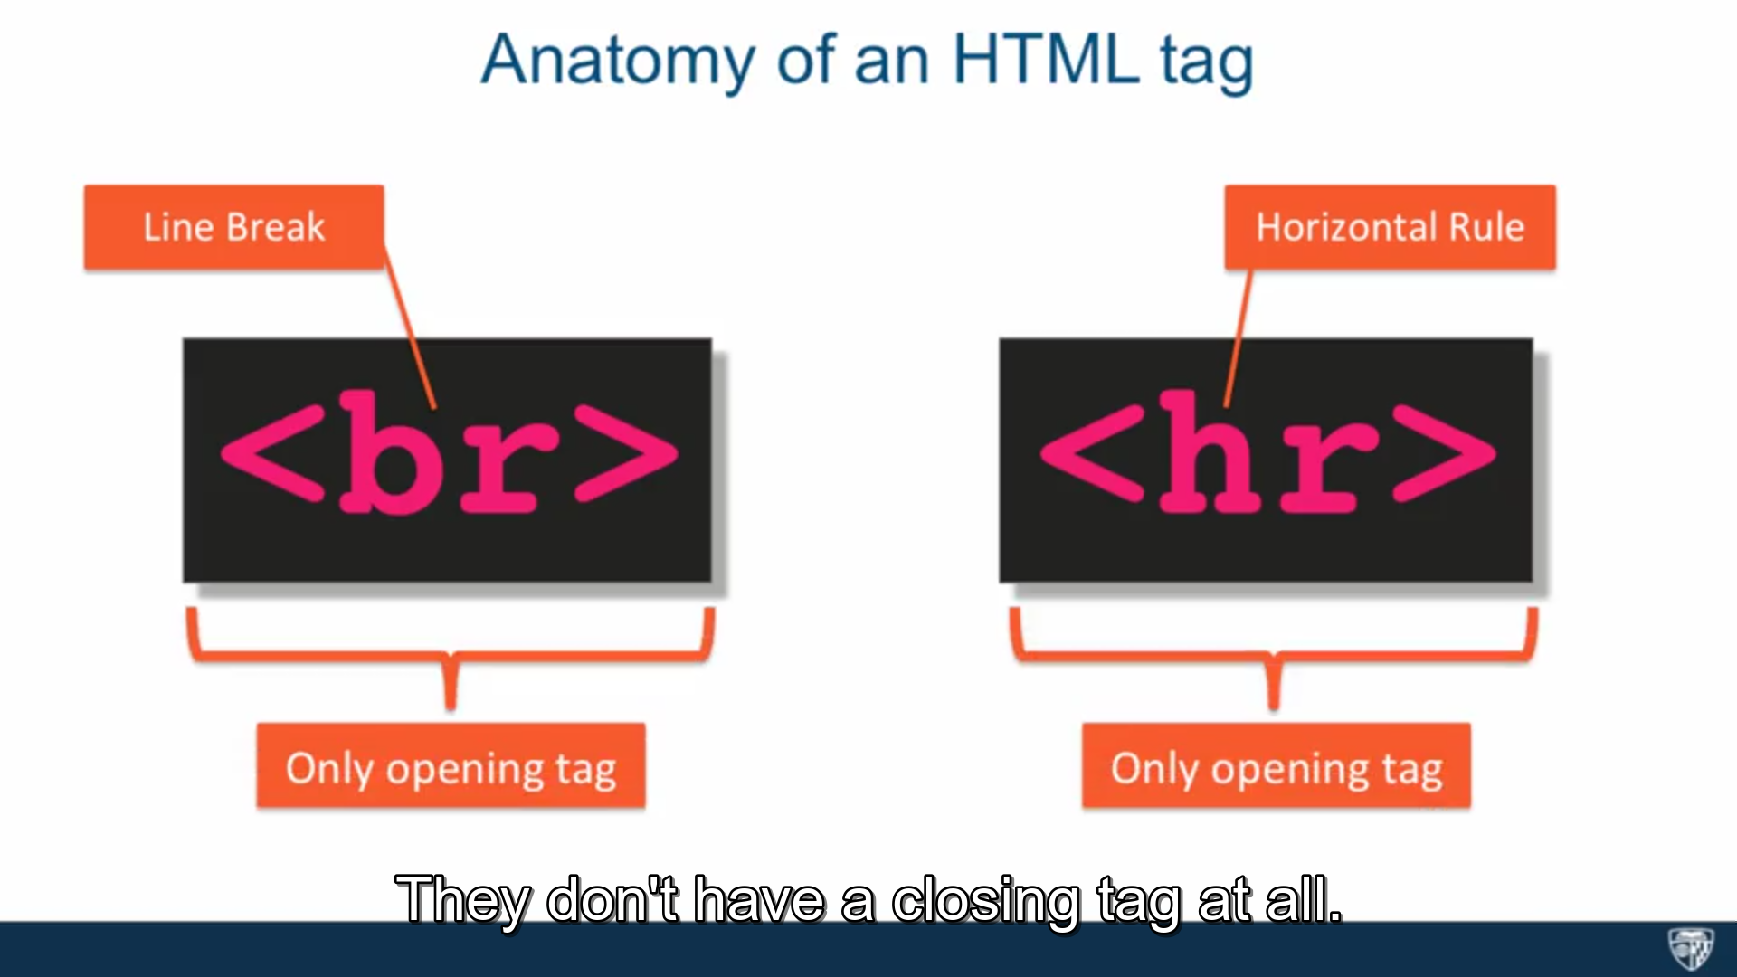

<br> and <hr> have only the opening tab and not the closing tab.

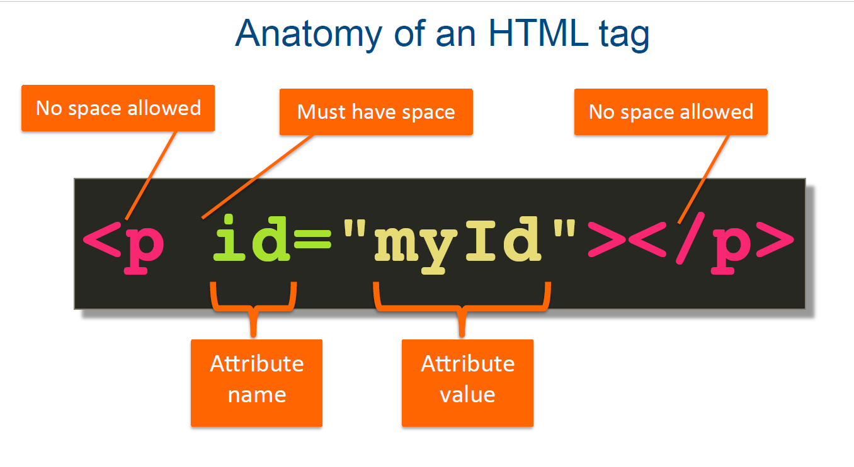

Attribute is a name value pair that is kind of meta data about the element that is being applied to. Attributes can be specified only in the opening tag and not in the closing tag.

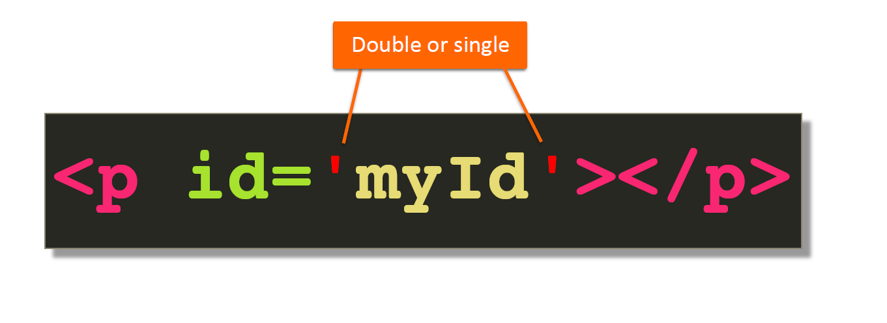

Not necessary to use only single quotes and not necessary to use only double quotes. We can use any quotes, but the type of opening and closing quotes should be same.

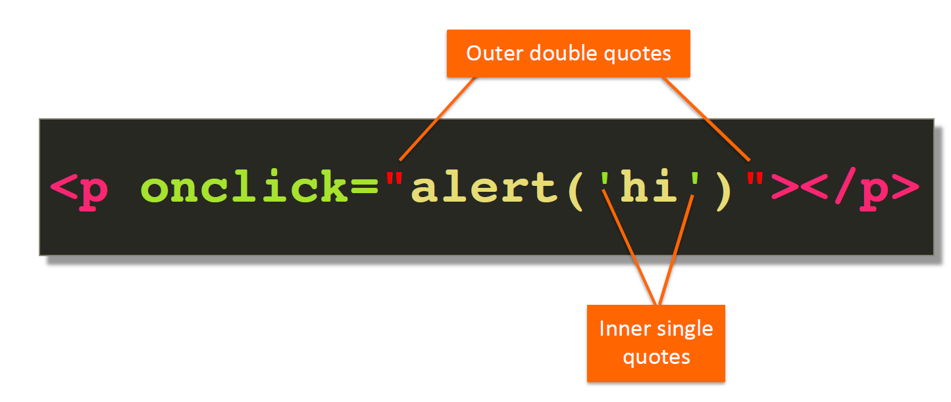

The outer and inner quotes should same with intact.

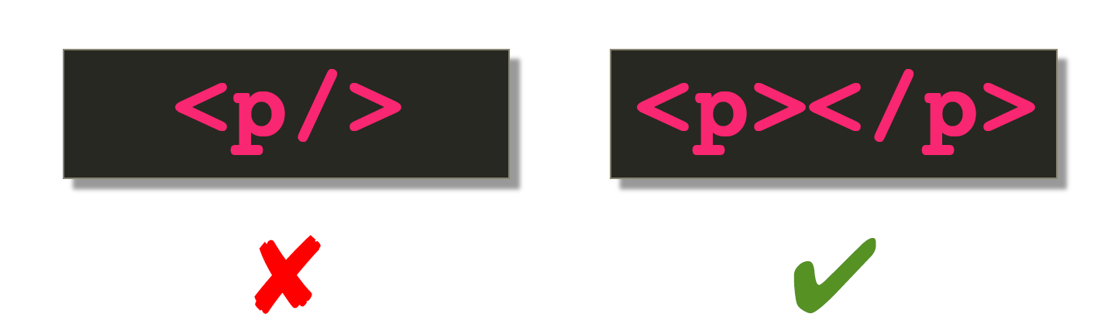

<meta> is a standalone tab, There is no closing tag for   
Normally 256 bits are required to show case our keyboard keys. But what if , if we want to include tamil, Japanese etc characters. That will be done by including ***<meta charset=”utf-8”>***

Doctype – Definition

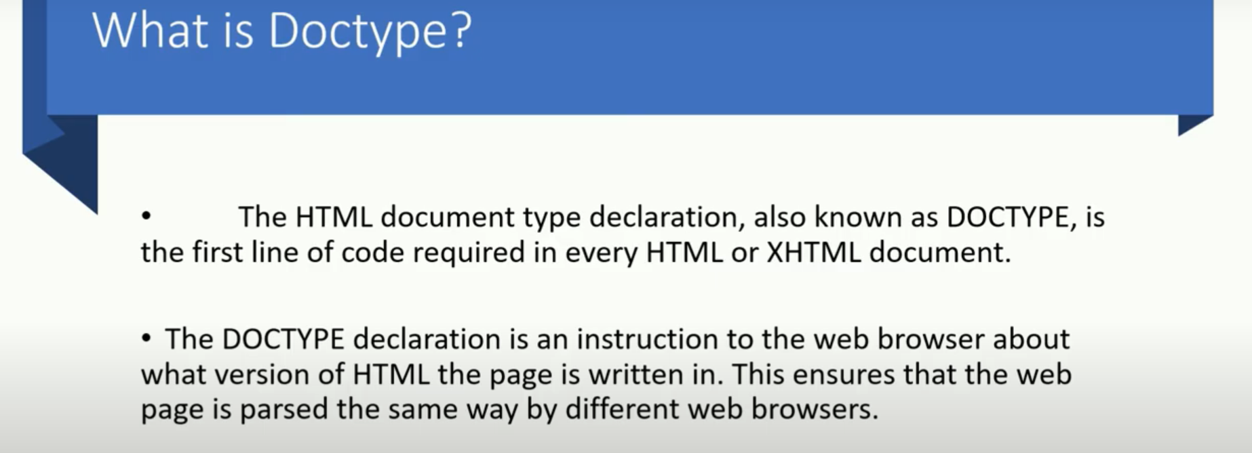

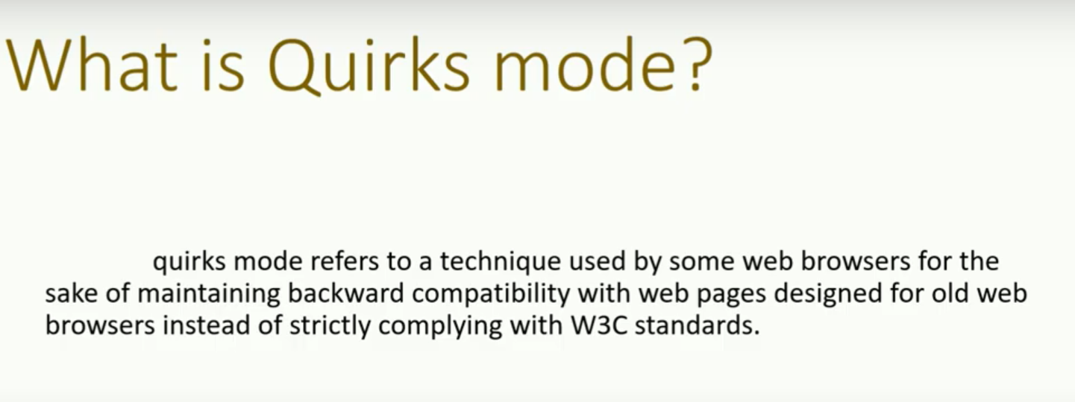

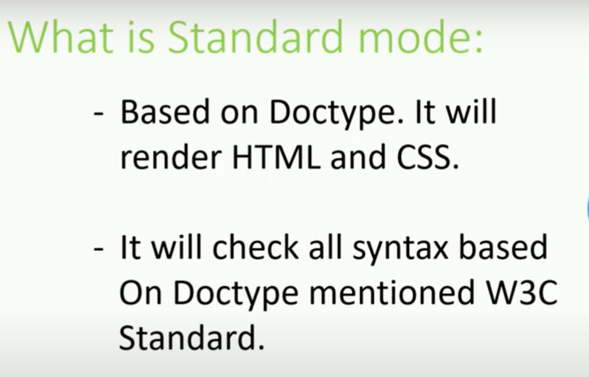

When the browser opens an HTML page it always renders/interprets the HTML code sequentially from top to bottom.

Quiz questions

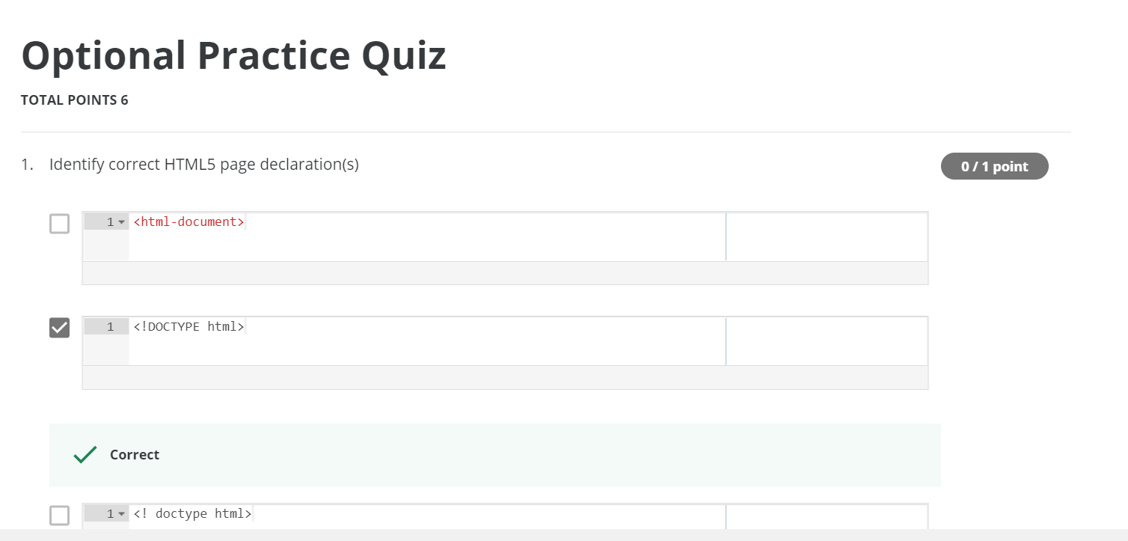  
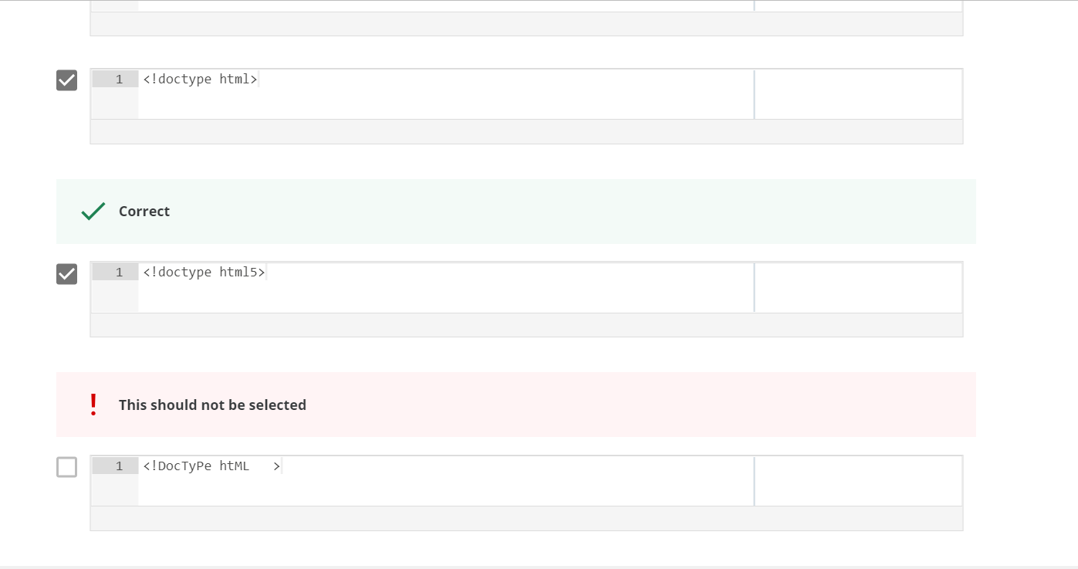  
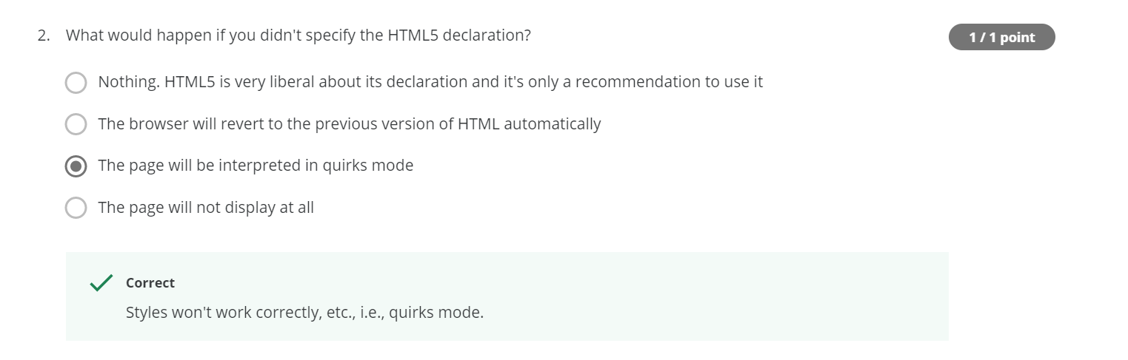  
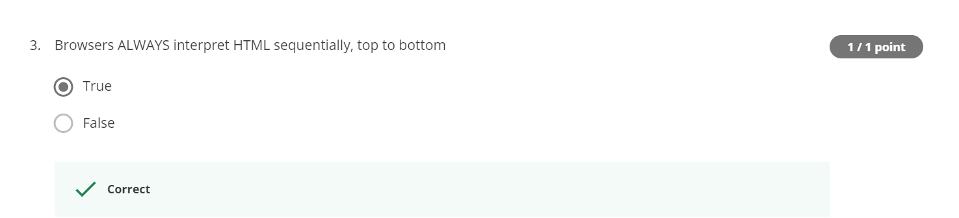  
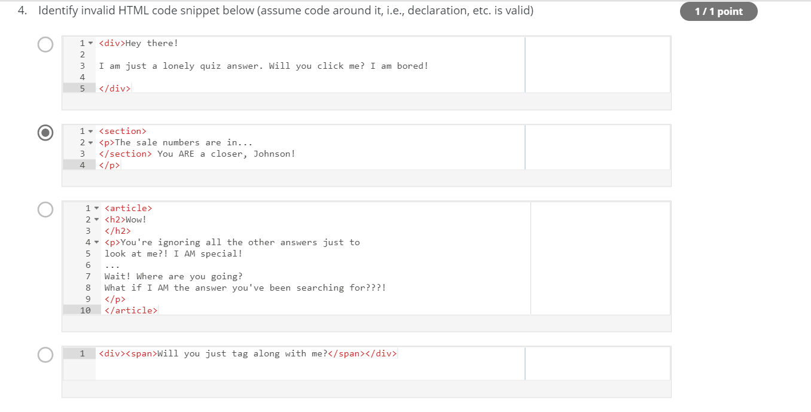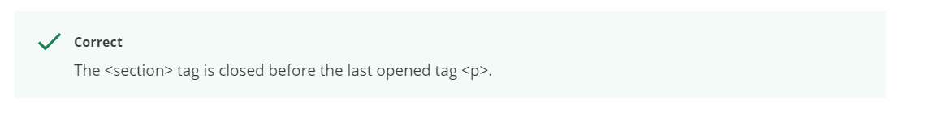  
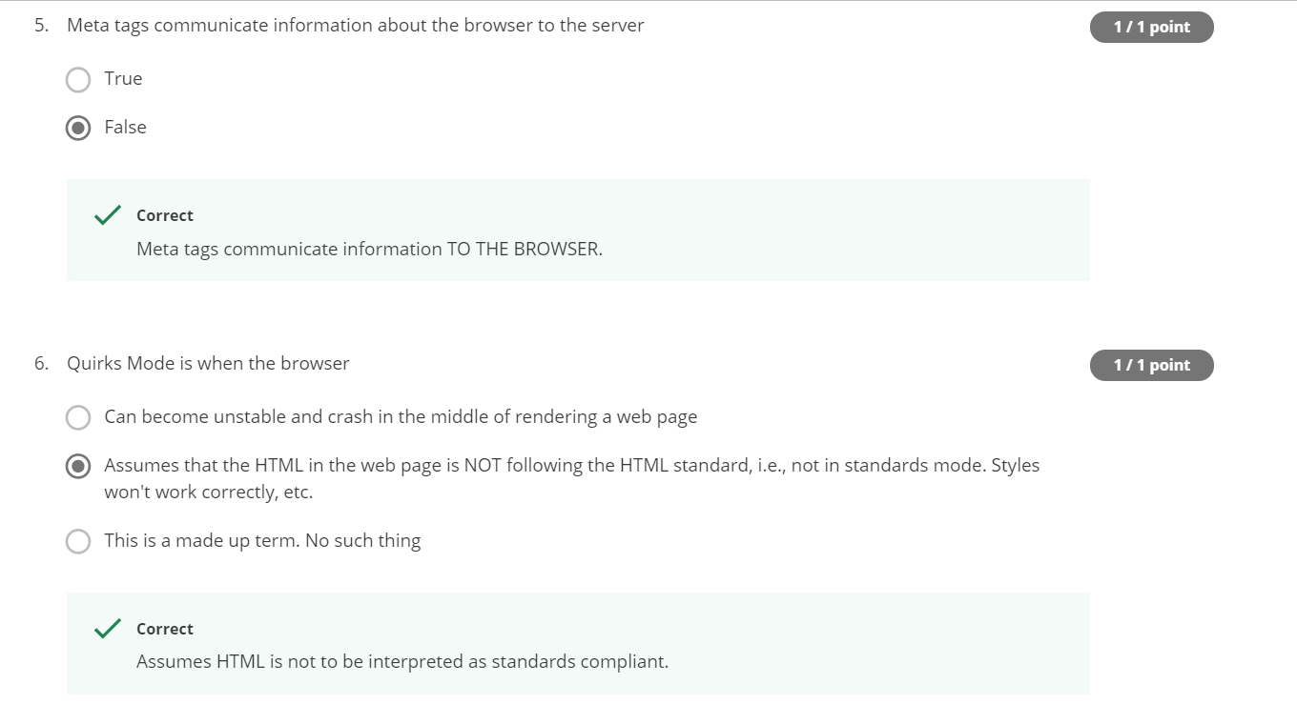

**<div> <span>**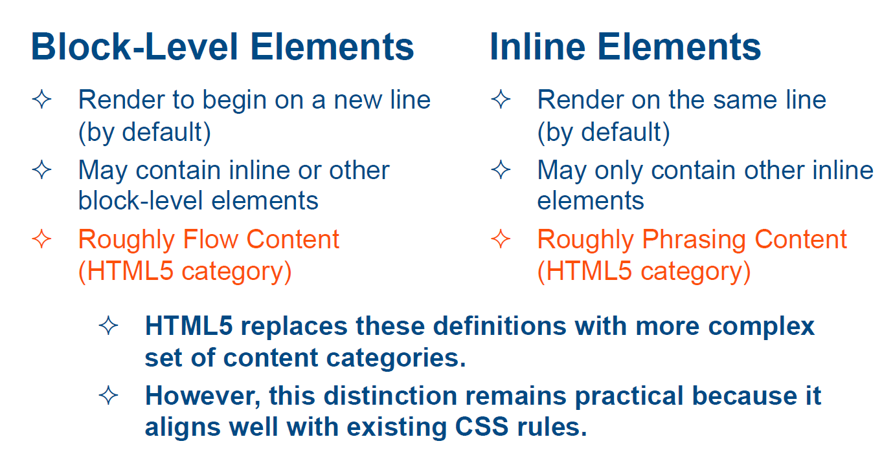



block-level tag takes up the entire line inline-tags will take the space only upto the content. and not the whole line.

<b> 🡪 bold  
<u> 🡪 underline  
<i> 🡪 italic

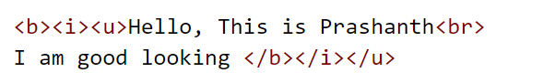



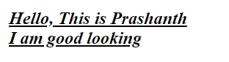

<br> tag to enter line breaks, not to add space between paragraphs.

Without <br>



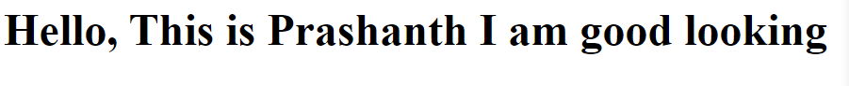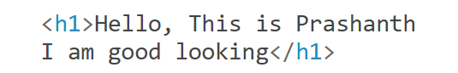

With <br>



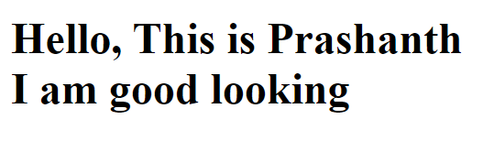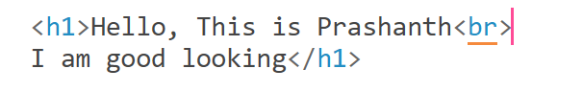



**Applying the font color**

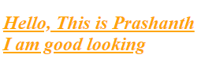

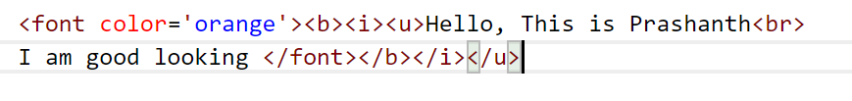

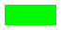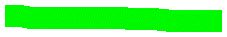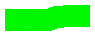

**Enclosing everything in the <span>**

Instead of coding the <font color=’orange’><b><i><u> every time for every line we can predefine it initially and can use with <span>

<span> is used when we want to introduce more than 1 style to the content.





I enclosed everything in the <span>, so as to avoid coding the entire style again.  
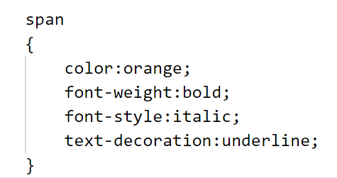

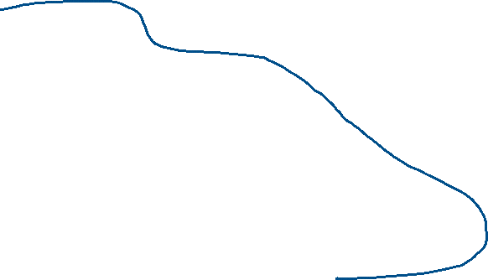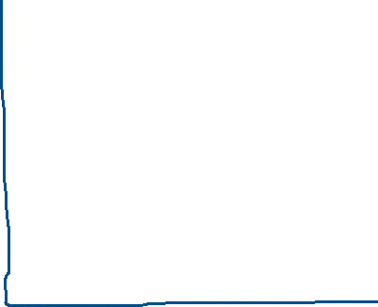

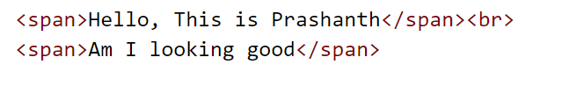

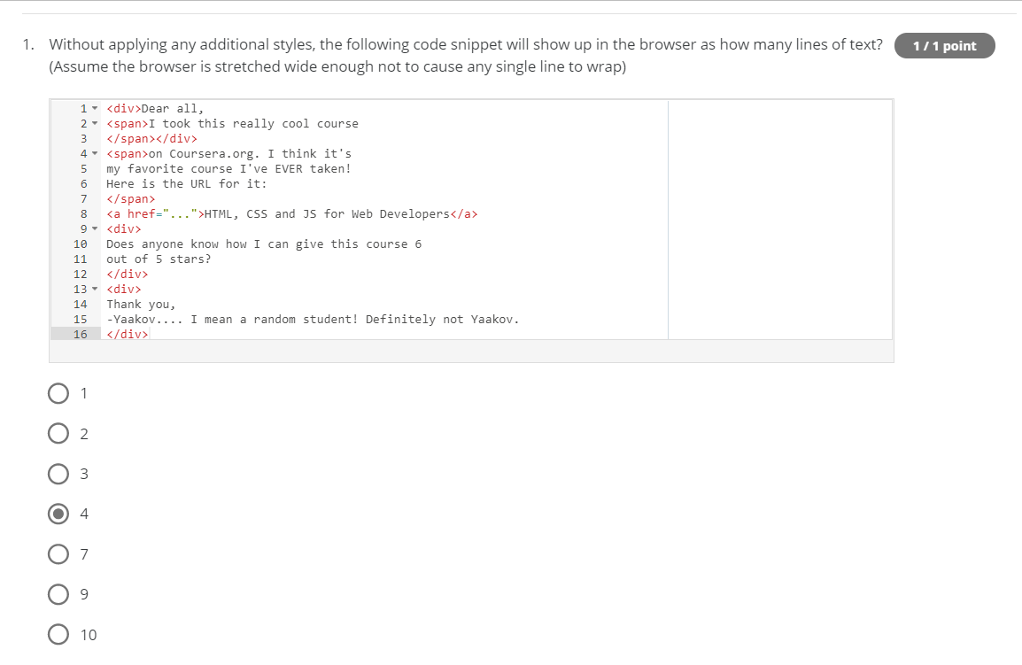  
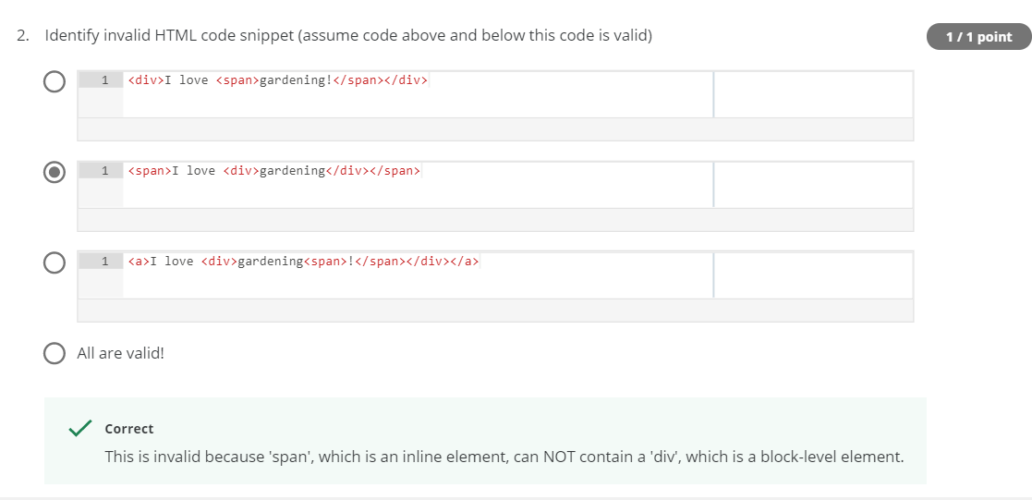

Always Inside <div> only <span> will come.

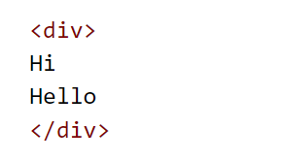the output will be in a single line.

***Lecture 6 : Heading Elements (and some new HTML5 semantic comments)***

**Semantic 🡪** related to meaning in language or logic

**Semantic html elements:**Element that implies some meaning to the content.

Seo 🡪 Search Engine Optimisation

**2 important points:**

* First, even though their default rendering in the browser appears to give them visual distinction, these should not be used for styling. These elements are only meant to convey structure of your HTML page, nothing more. With CSS, any regular development can be styled to look like any one of these heading tags.

So, why not just use a div?

Because if we did, we would lose the meaning of what a heading is.

* Second, something that's marked h1 is obviously the most important and generalized description of the content of this page. And while there are disagreements among the SEO experts about how effective these semantic tags are for helping your search engine rank in general, everyone agrees that when it comes to the heading tags, and specifically the h1 tag, that it is of utmost importance to use it and that it should contain the wording, which truly conveys the central topic of the rest of the content.

**Explanation:**

<h1> 🡪 conveys the most important heading in the web-page.  
<h6> 🡪 conveys the least important heading in the web-page.

If I want to mention my most important heading in the style of <h4>, then the semantic meaning of most important heading will not be preserved.  
In order to with-stand with the meaning of most important heading but I want the font size to be some small than regular <h1>, you have to use the <h1> to convey the meaning and the font-size of the tag can be adjusted using CSS.

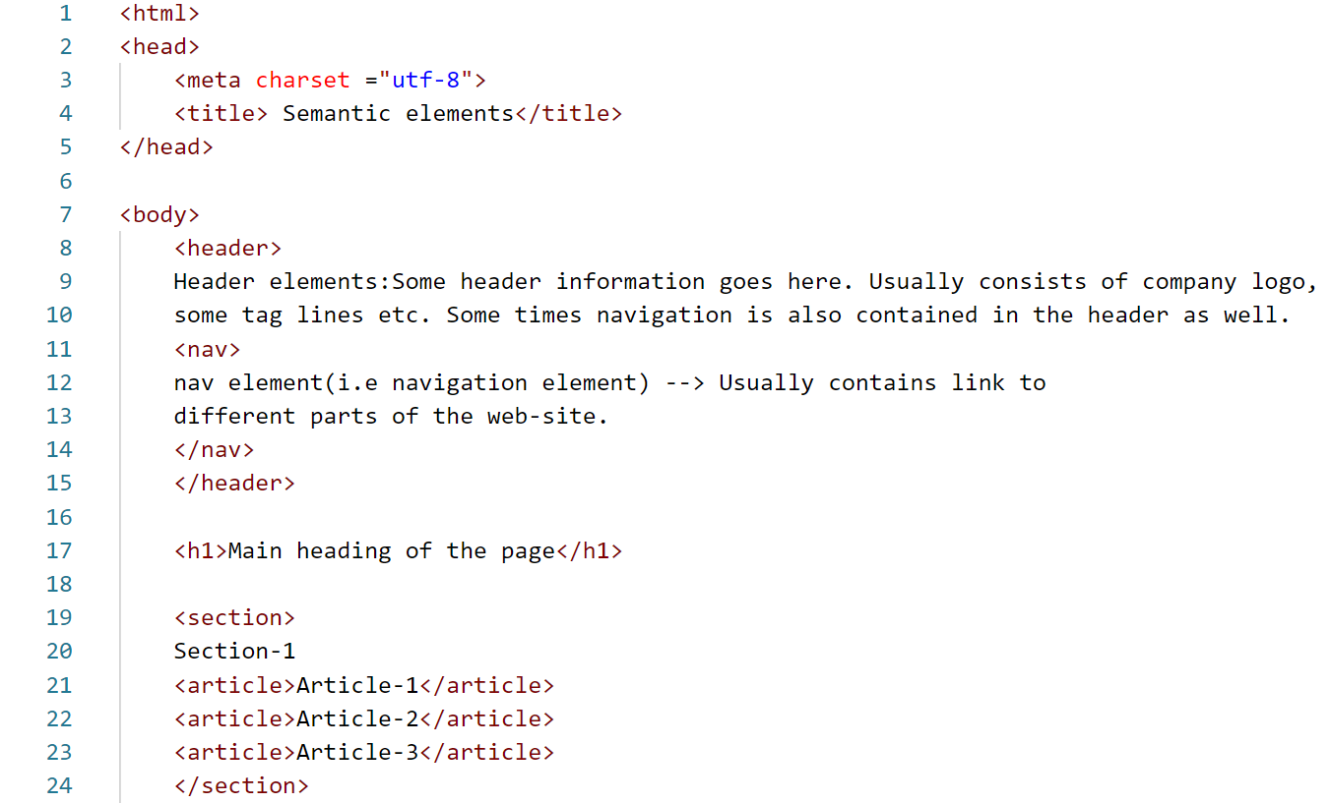 ,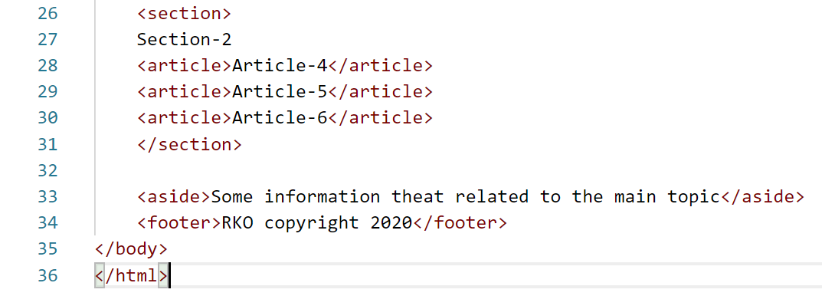

<nav> , <section> , <article> <aside> <footer> are all block level tag. Now the question arises,if all are block level tags then why can’t we use <div>??? With <div> no significant meaning can be figured out from the html code 🡪 Semantic meaning doesn’t holds good.

**Conclusion:**

Semantic elements allows for a more meaningful expression of the structure of our HTML page.

**Quiz question**

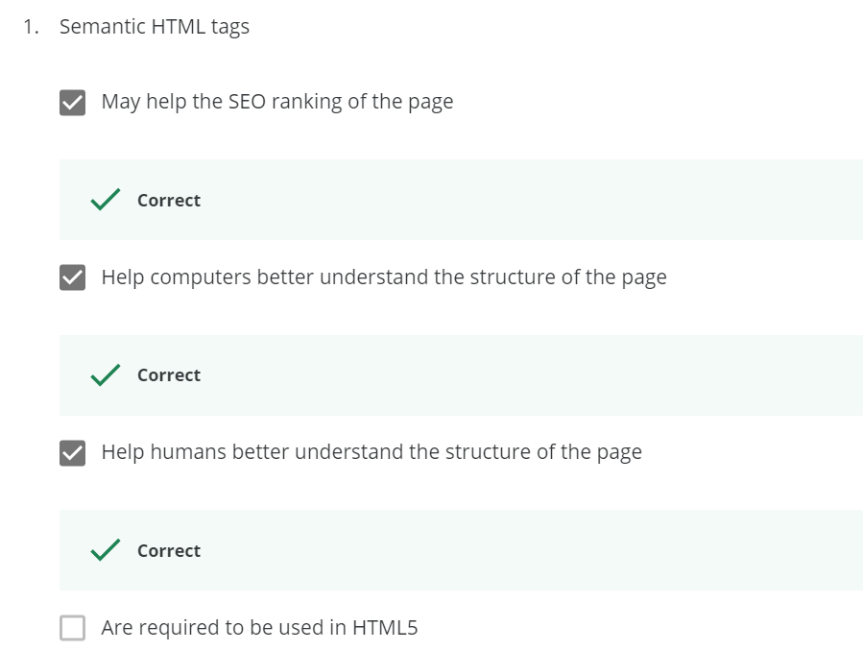

***Lecture 7 : Lists***

1. Un-ordered list :

An unordered list starts with the <ul> tag. Each list item starts with the <li> tag. Inside <ul> only <li> must be present, none of them are allowed. The list items will be marked with bullets (small black circles) by default

My dinner items

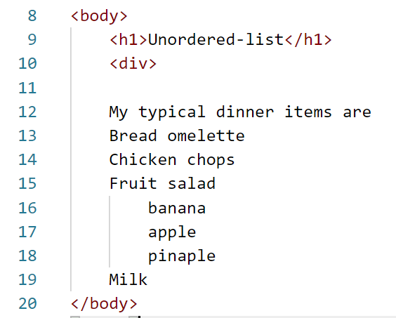   
These items are un-ordered, Now I am going to group these items in a separate lists. The fruit salad items are also to be grouped. Fruit salad items are grouped in a manner of list within a list.

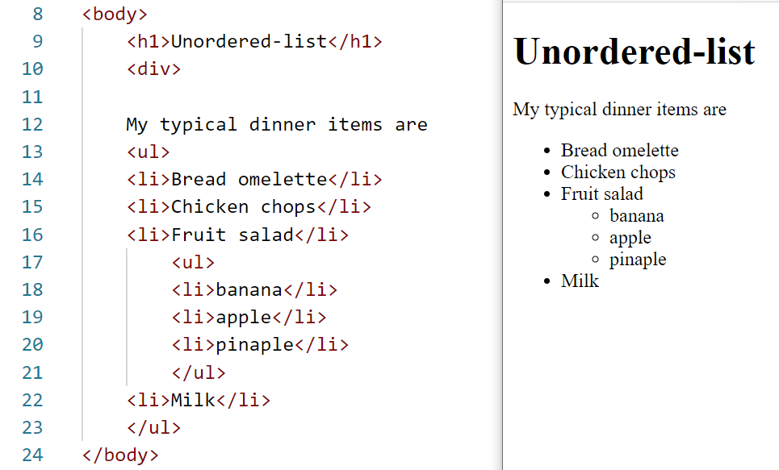

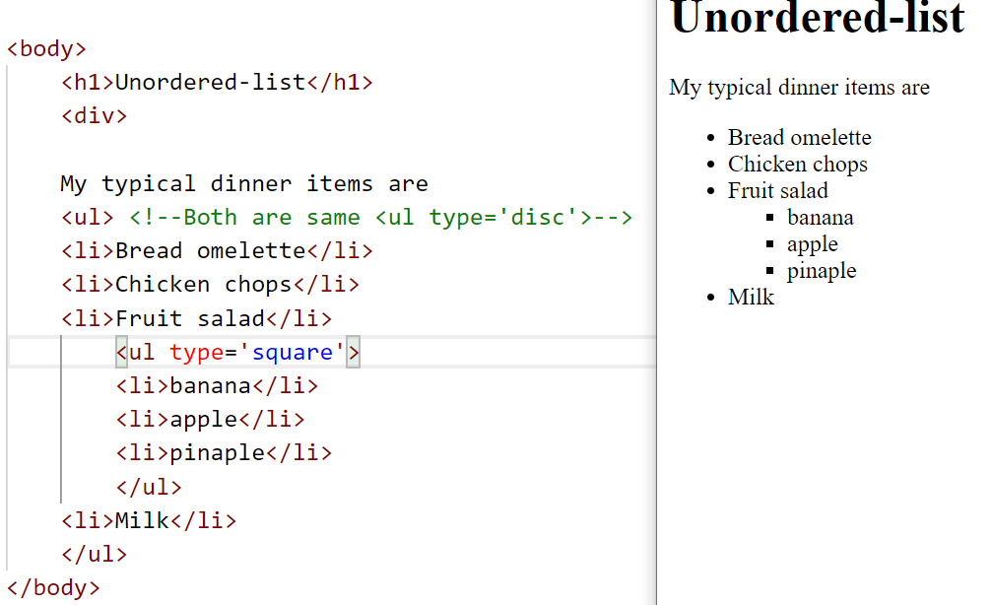



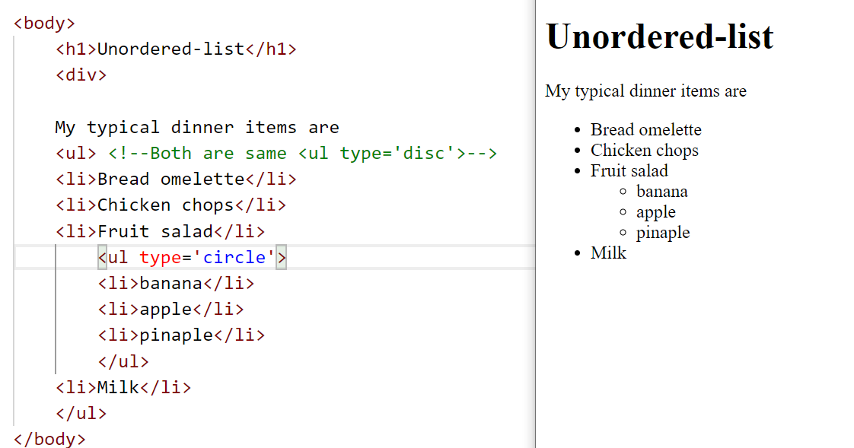



List with No symbols

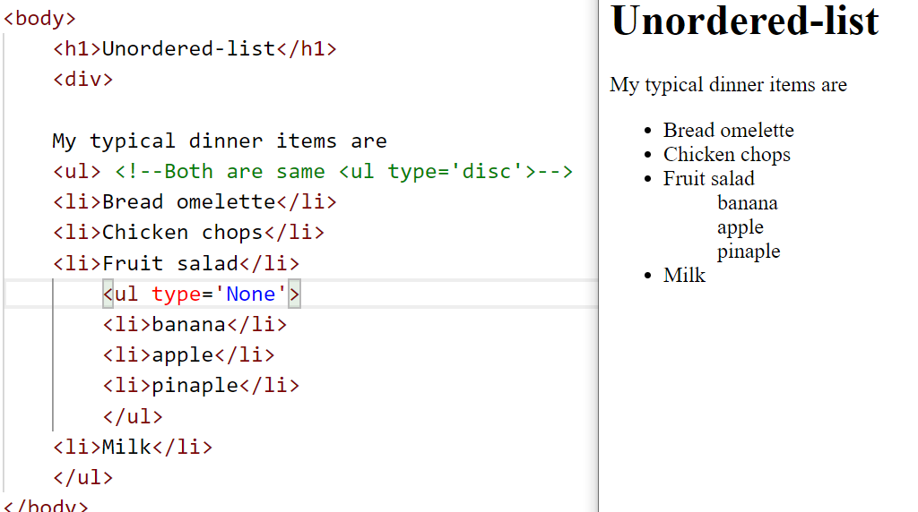



Including the symbols from the images

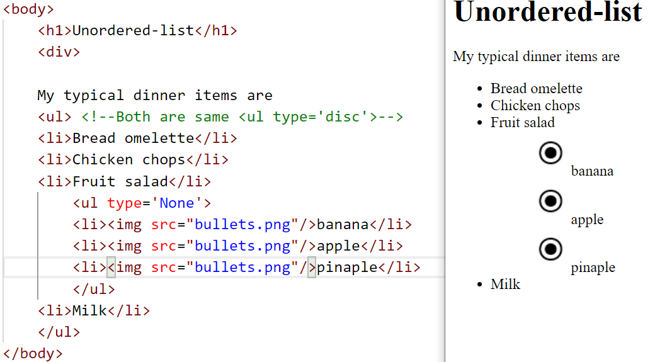



ii) Ordered list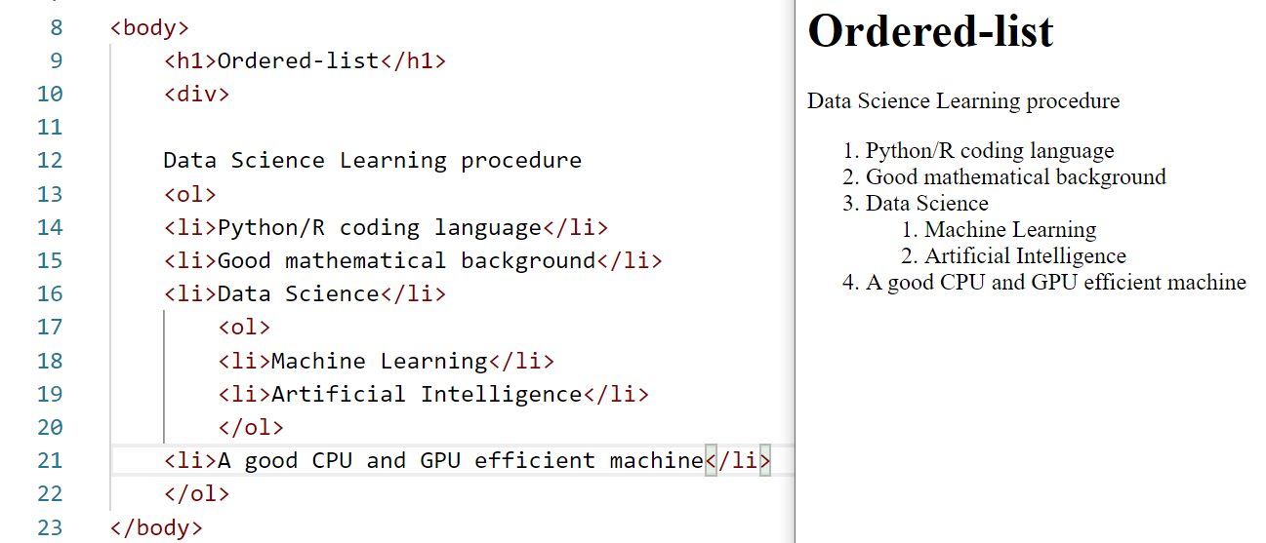

Conclusion :

List provides a natural and commonly used grouping of content.  
Very often, lists are used for structuring navigation portion of the webpages.

***Lecture 8 : HTML character entity references***

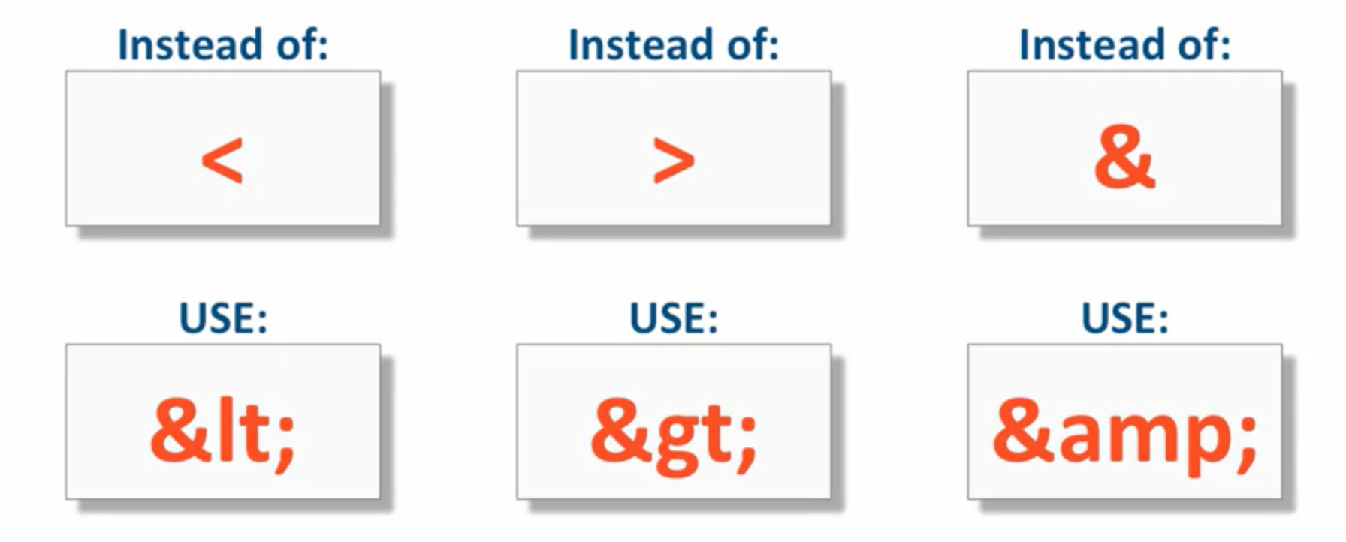

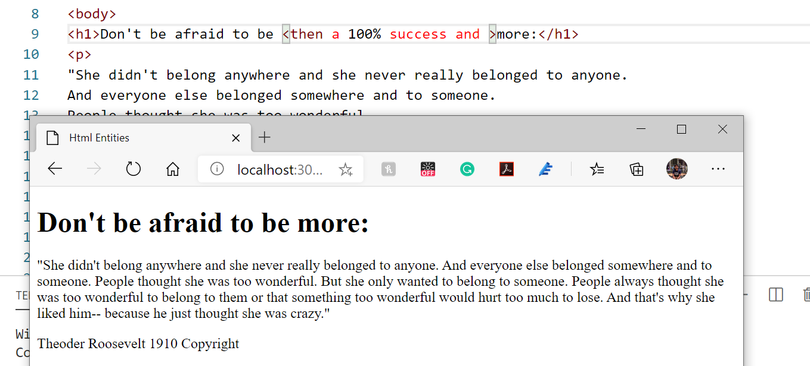

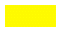

HTML considers the less and greater than symbol as a separate tab. Instead use this

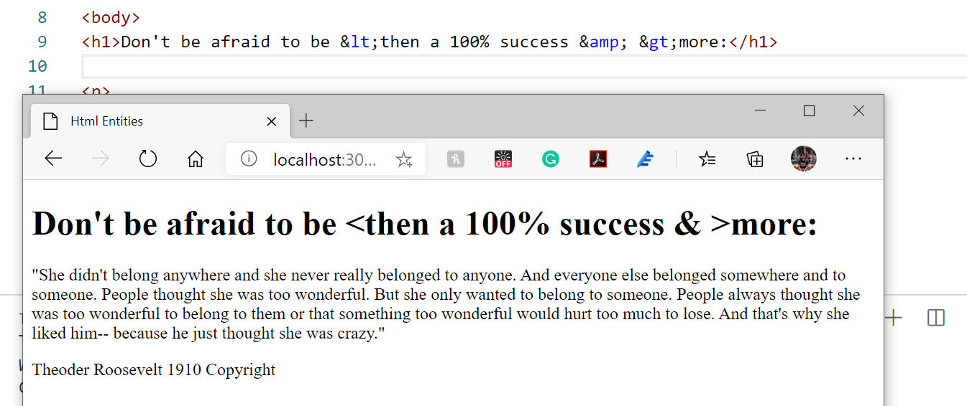



Copyright entity reference 🡪 &copy;

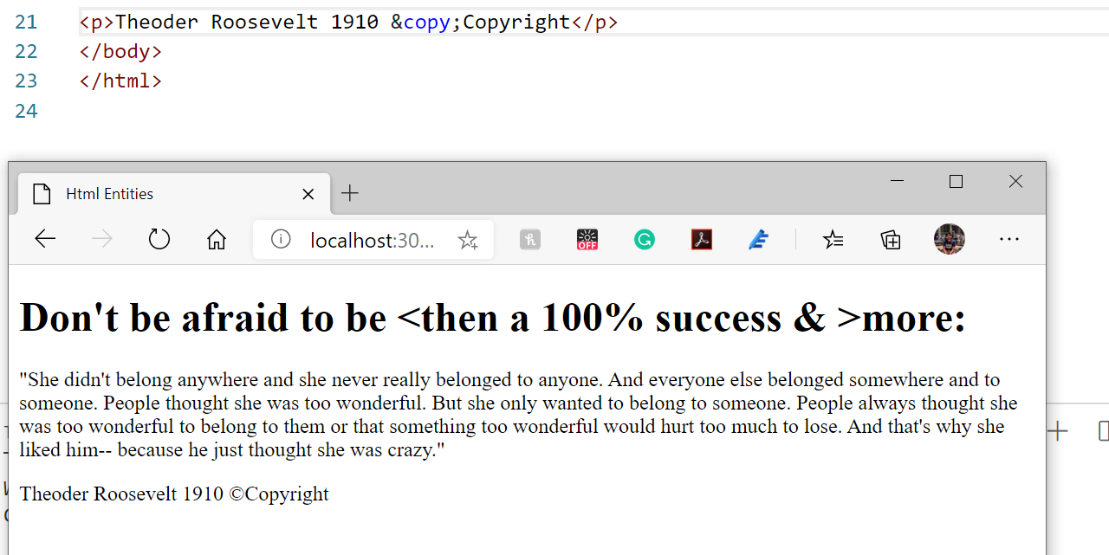

Non-breaking space entity reference 🡪 &nbsp;

It is used when we want some text not to be broken in-between when we shrink the browser size.

Before shrinking :   
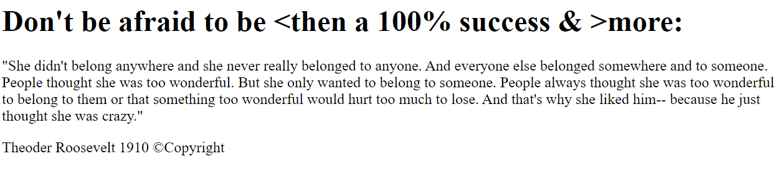



After shrinking the browser size :   
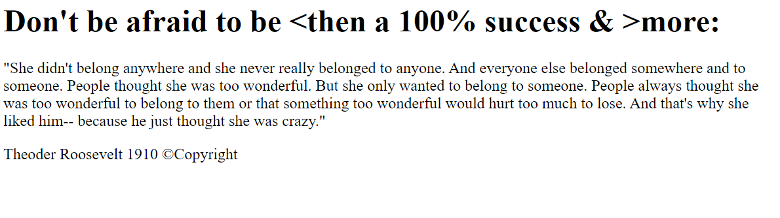

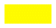

After using &nbsp;

Before shrinking :   
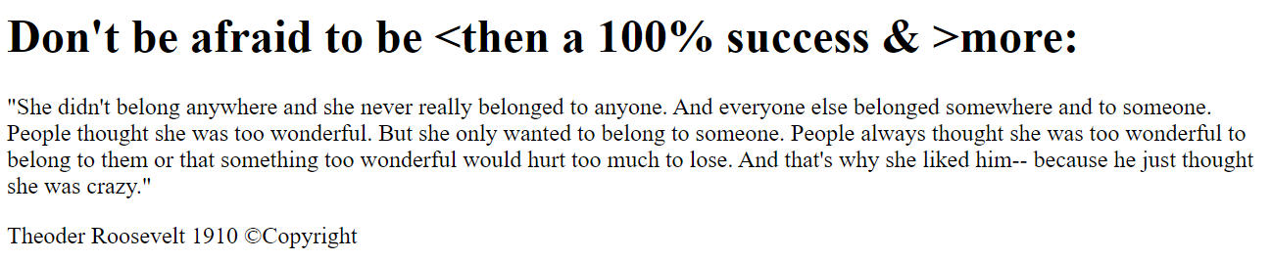



After shrinking the browser size:

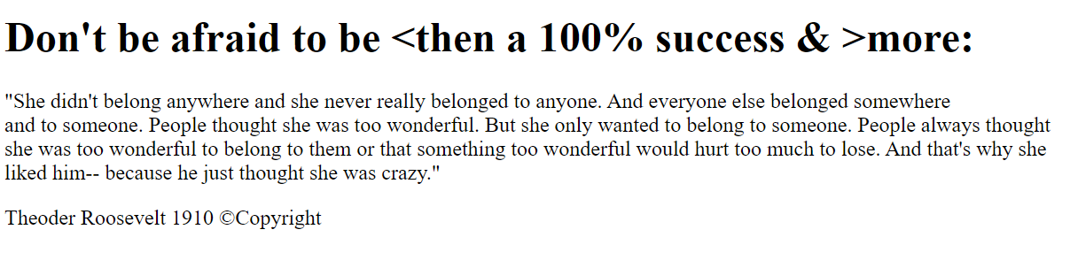

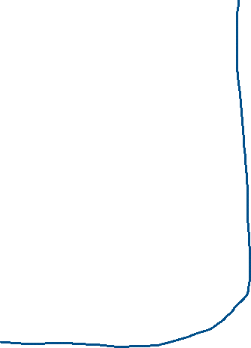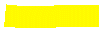





The non-breaking tag didn’t allowed the phrase “and to someone” to break in-between when the browser size is shrinked. But without using &nbsp; the phrase “and to someone” is shrinked.

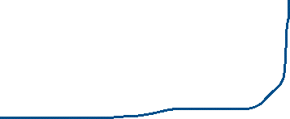

################################################################

&quot; 🡪 Can be used in place of single and double quotes

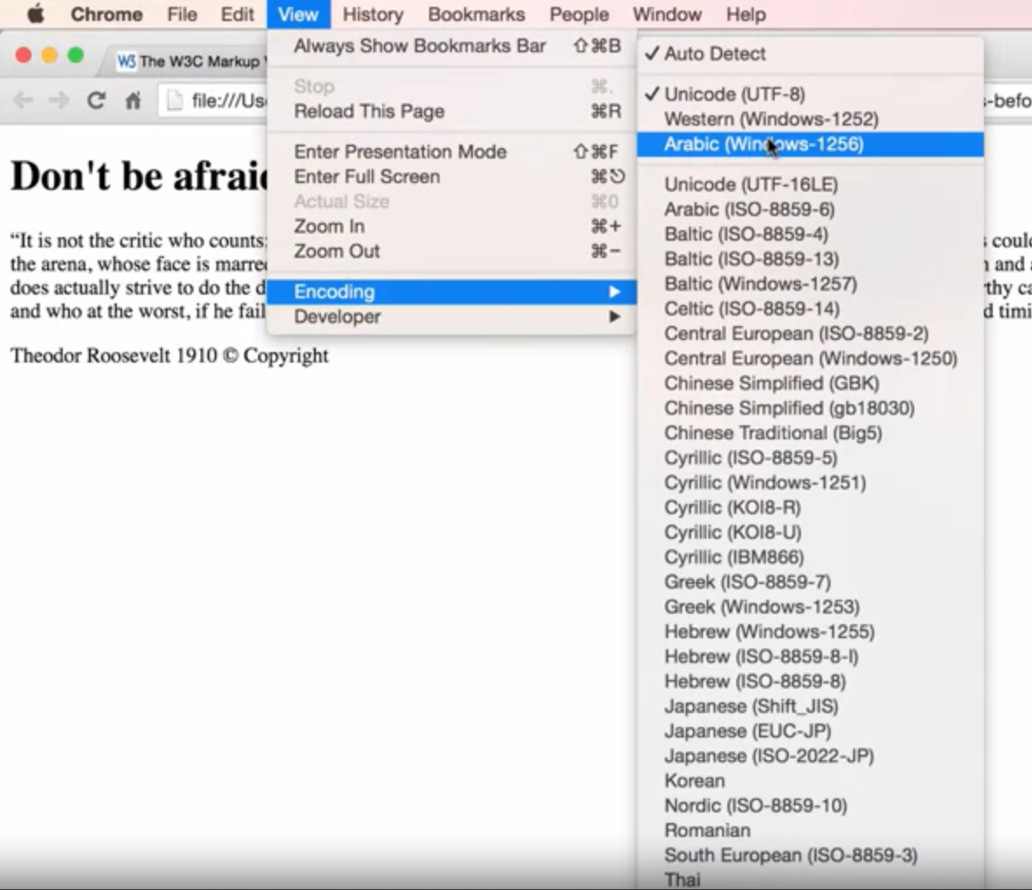



After changing the font style, the double quotes appears to be weird. This can be solved by using &quot;



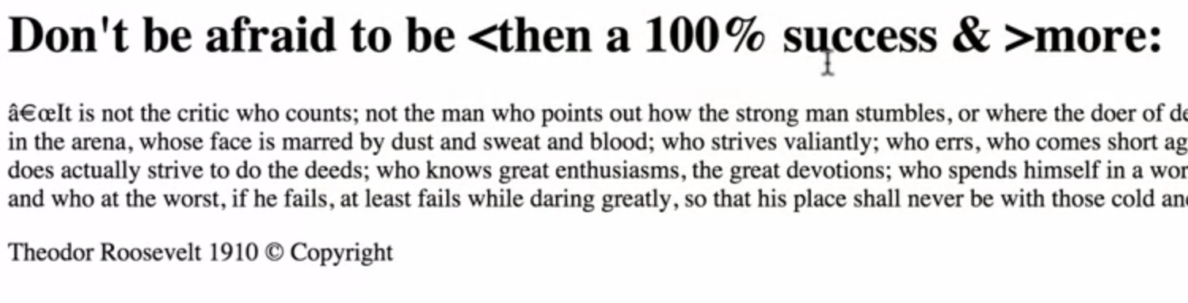  
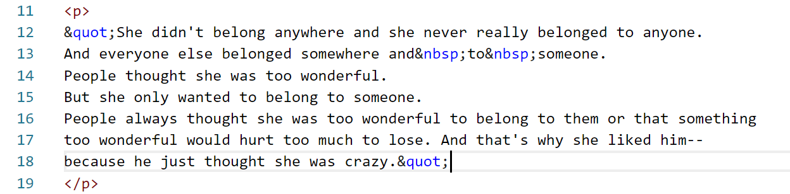



Quiz questions

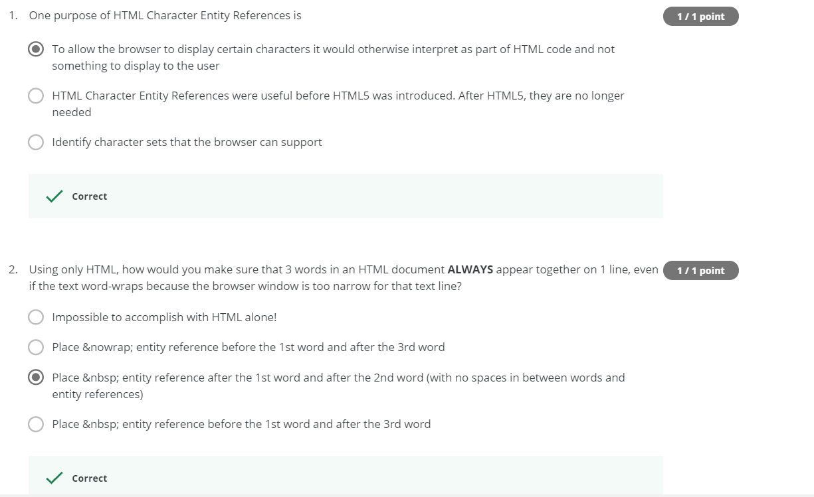

***Lecture 9 : Creating Links***

**Internal Links**

href 🡪 Hyper text reference

<a> is basically and inline tag. But it serves as both flow content (i.e inline element) and phrasing content (i.e block level element) if <div> is given.

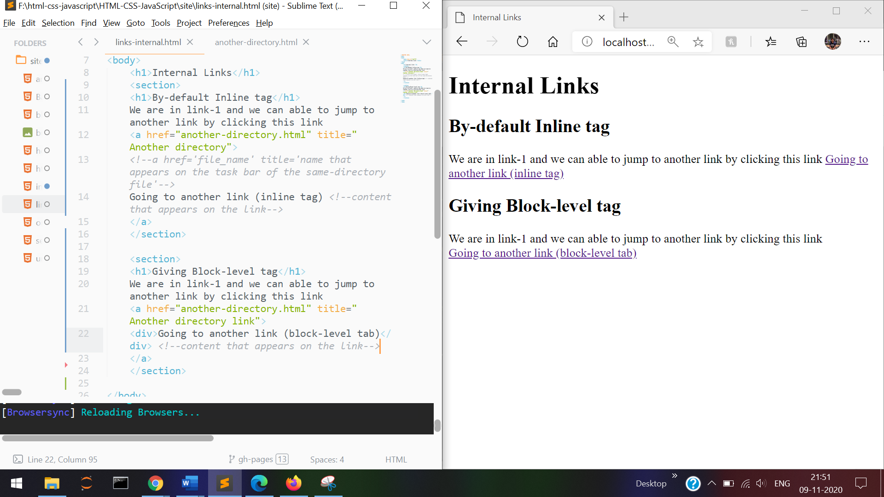

**<a href > </a>**  🡪 By default it is inline tag  
**<a href > <div> </div> </a>** 🡪 We can also make as a block level tag

**External Links**

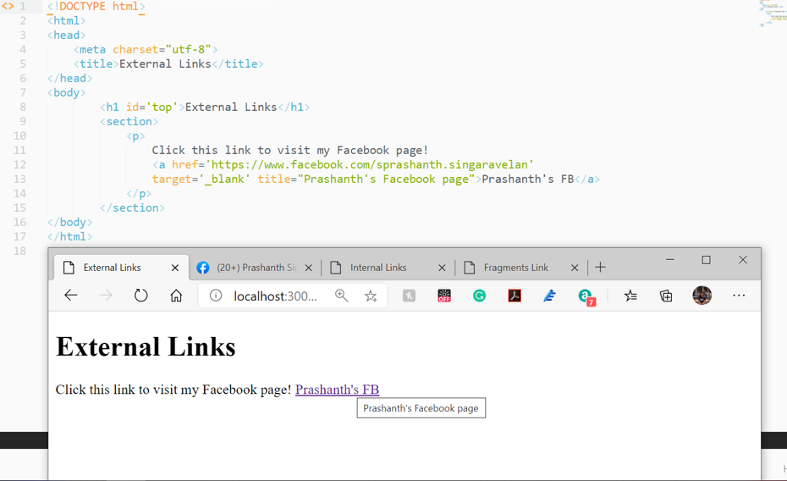

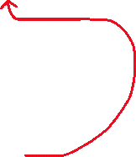

<target=”_blank” 🡪 The newly clicked link will open in a new tab/new window.

**Fragment Links**

Fragment identifiers are very useful in-order to jump to different parts of the same page. Used in navigating SPA(Single Page Application)

There are 2 methods of referencing and identifying the section

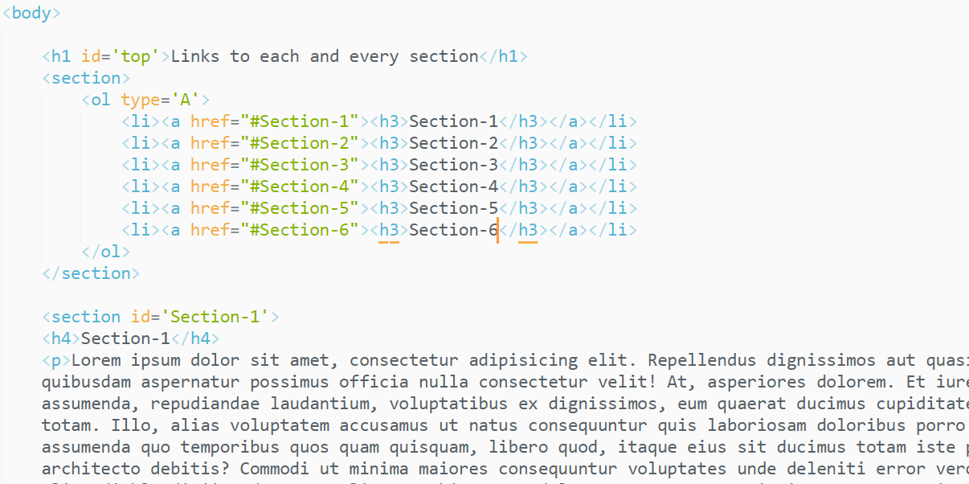



Each and every section will be identified only by its section id.  
Remember 🡪 <section id=’Section-1’> should not contain ‘#’ symbol.   
Only the link to that section should contain ‘#’ symbol.

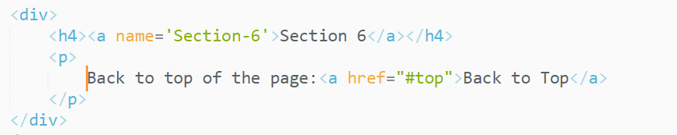



Going to top of the page

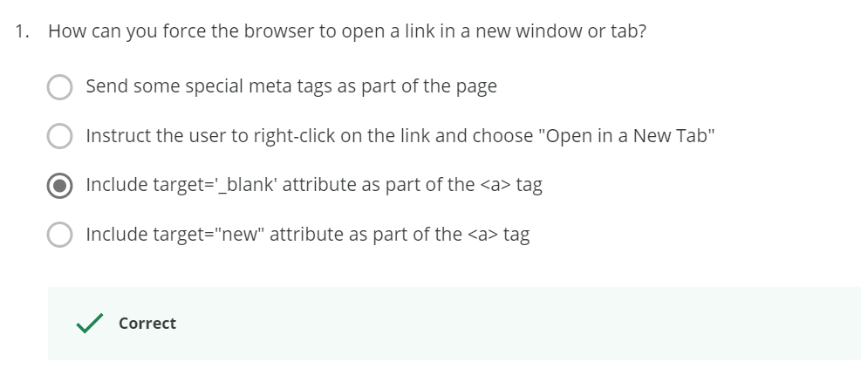

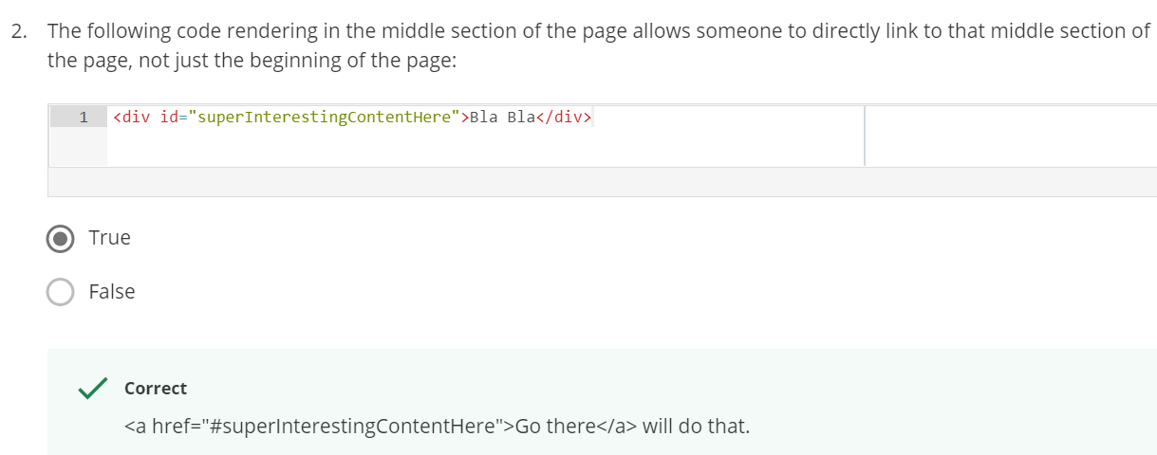

**Displaying Images**

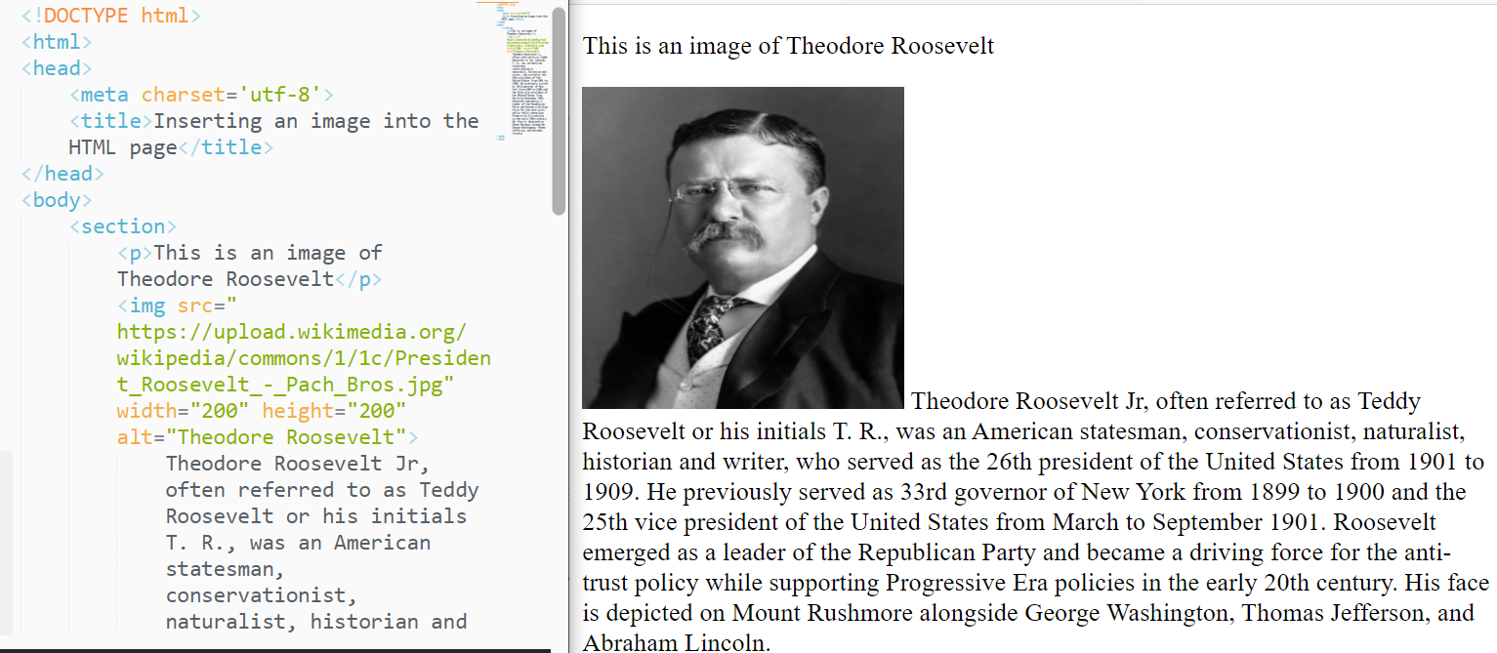<img src=”Theodore Roosevelt.img”> is an inline tag, since after the image the text is following in the same line.



Inserting a photo from the local pc

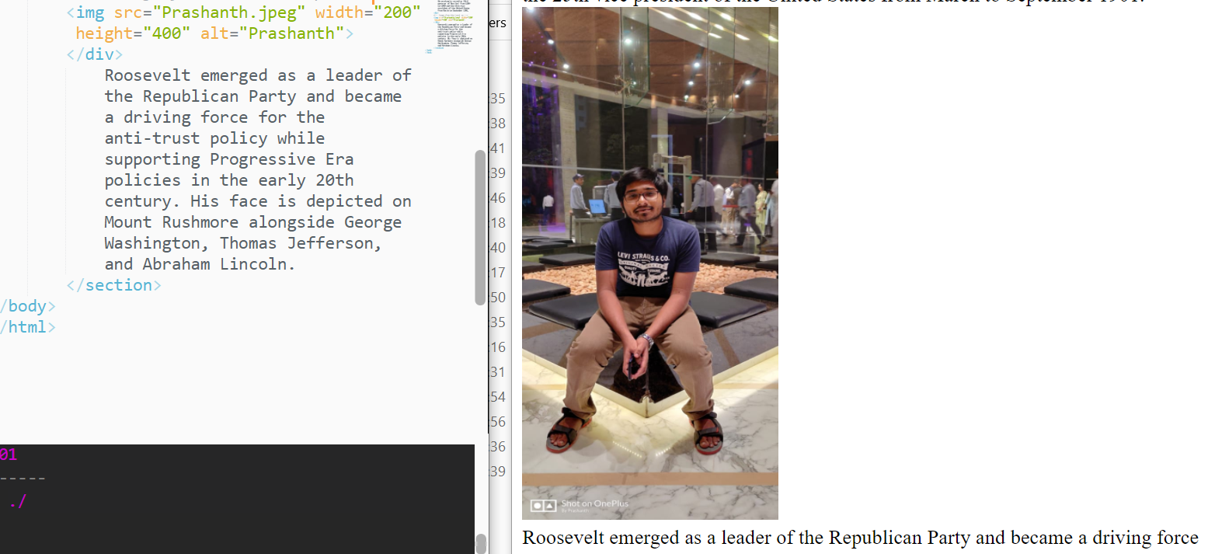

Purpose of width and height

width and height will help us to choose the width and height of the image. This will be useful when the image reloads.

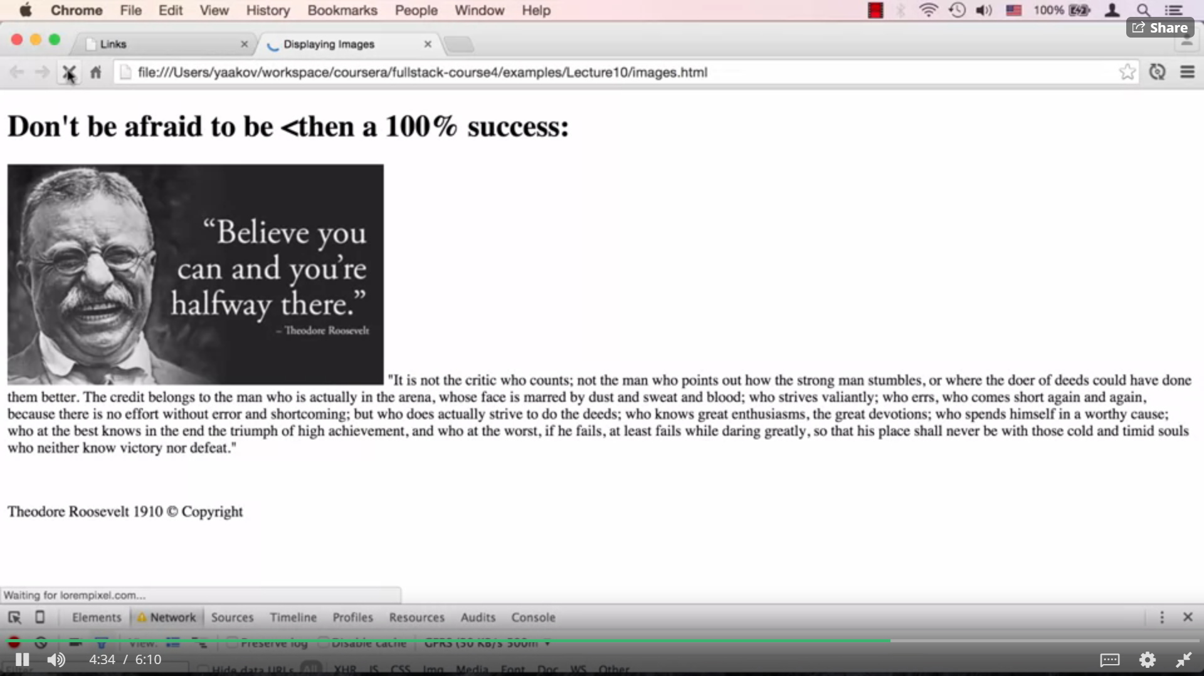



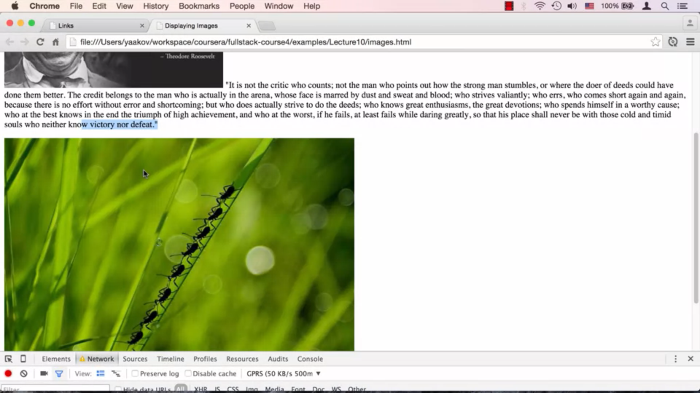



Before the browser doesn’t know whether the image is present/not.  
Before the image reloads , the user thinks that there are no image.  
So the user might skip and go to the next content.

One the other hand if the user knows there is an image yet to appear but the internet connectivity is low, the user will wait for the image to reload.

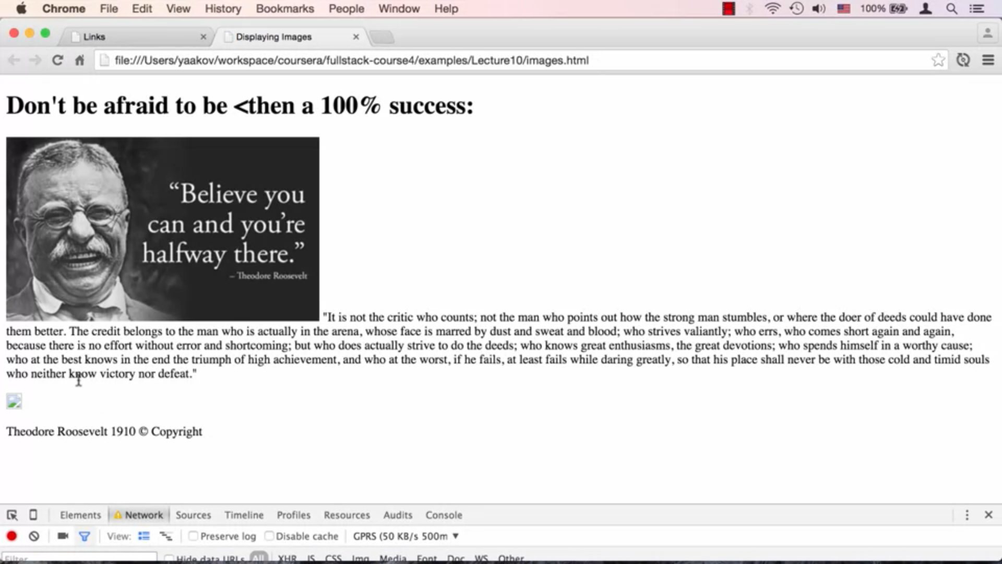

If the url name is wrong/internet connectivity is low . There appears an image was about to come.   
But we don’t know how much big the image is going to be if we didn’t mention the height and width of the image.

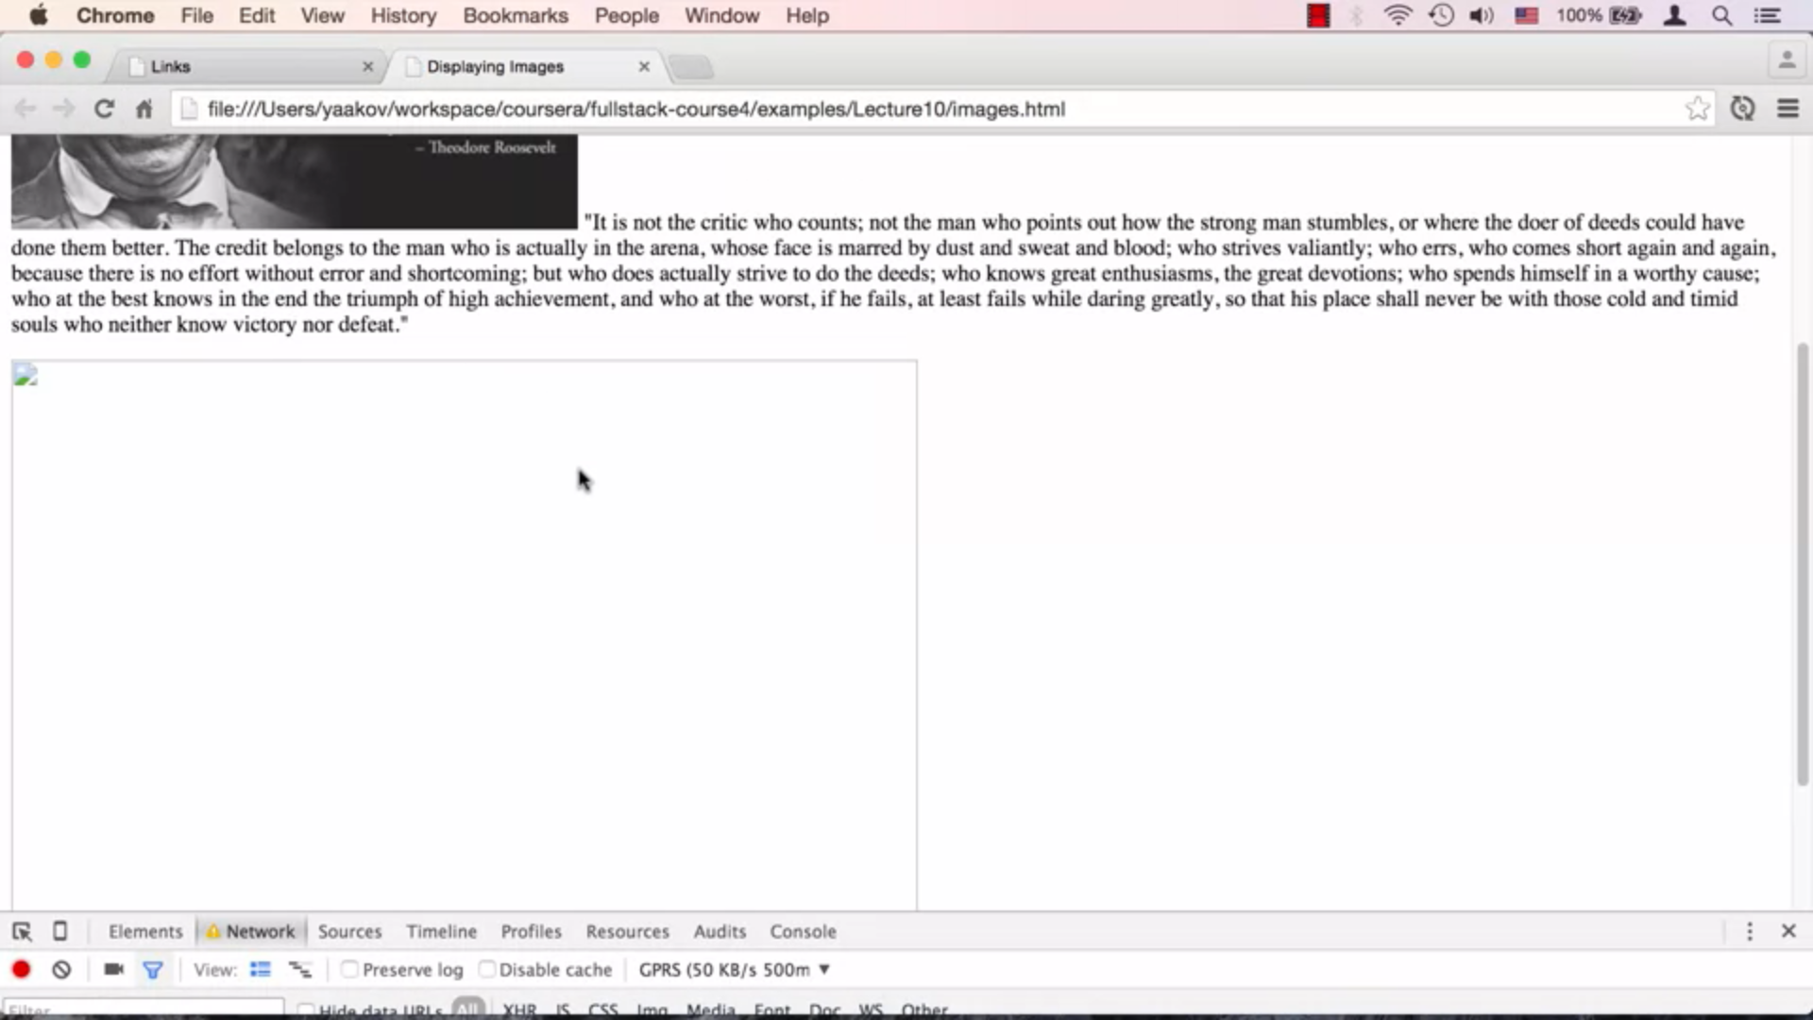

If we mention the height and width of the image, the actual size of the preview image will appear.

Quiz:

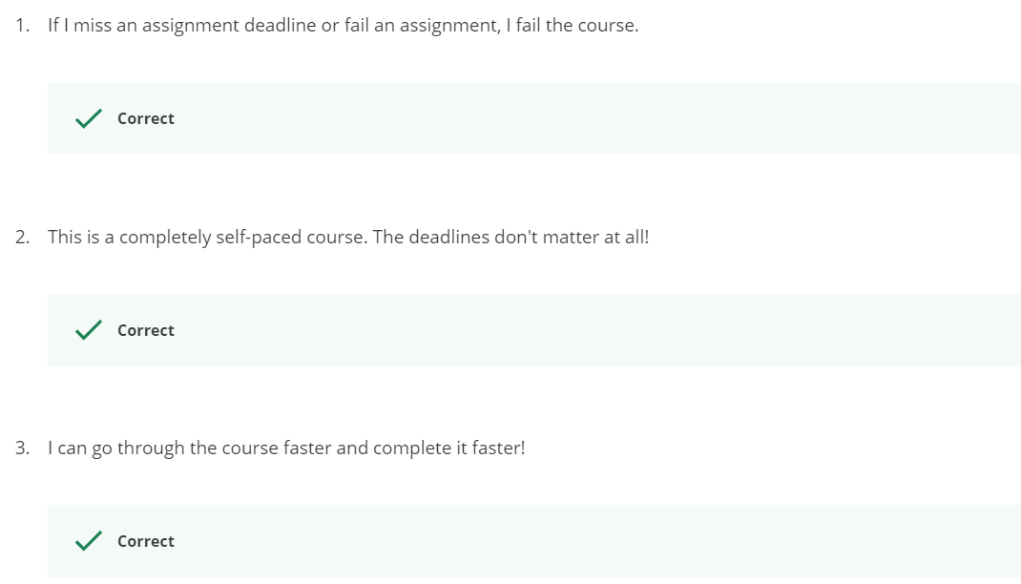

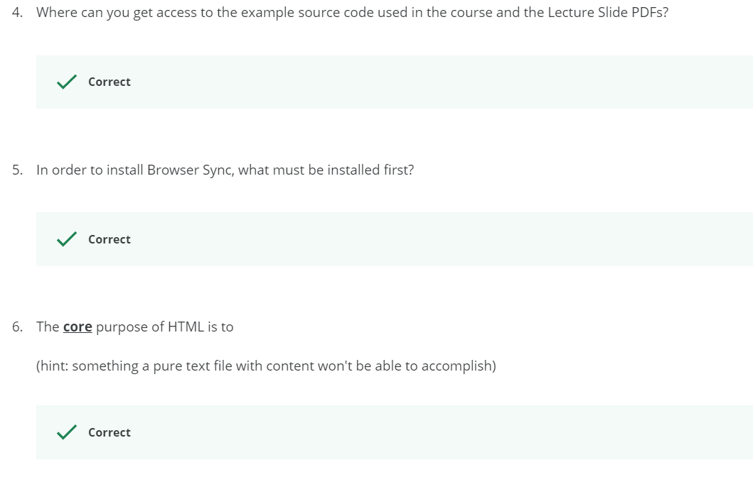

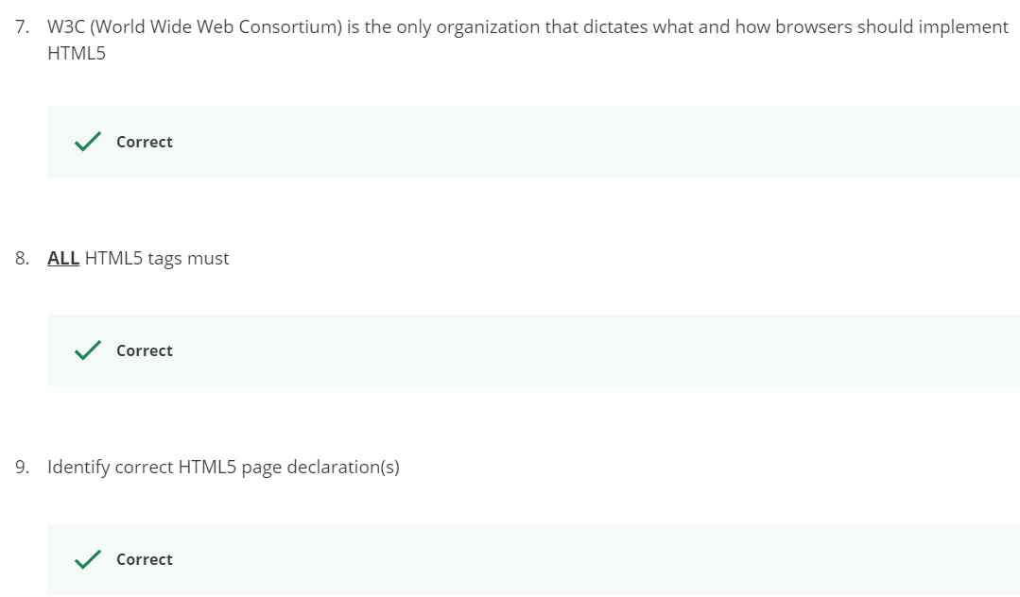

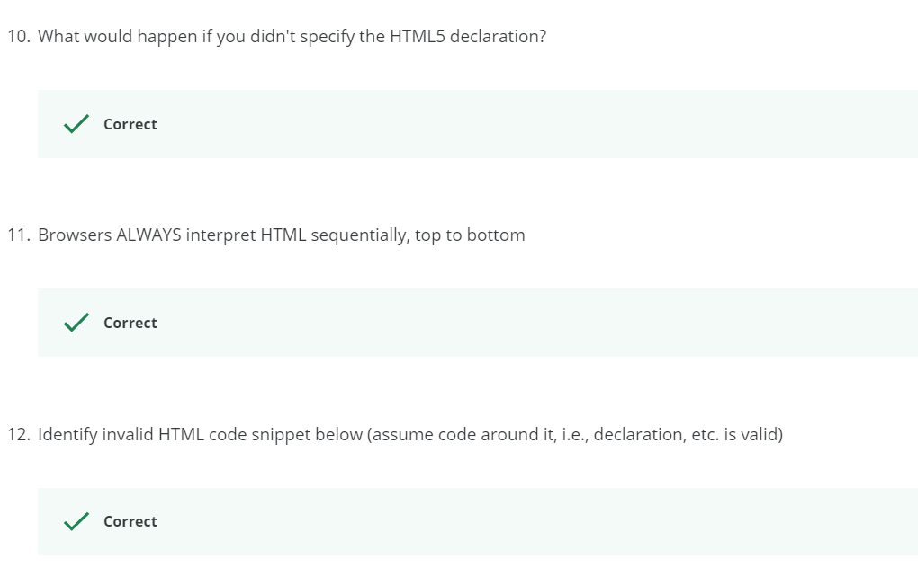

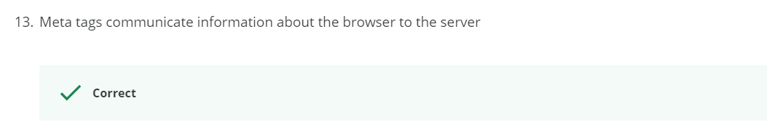

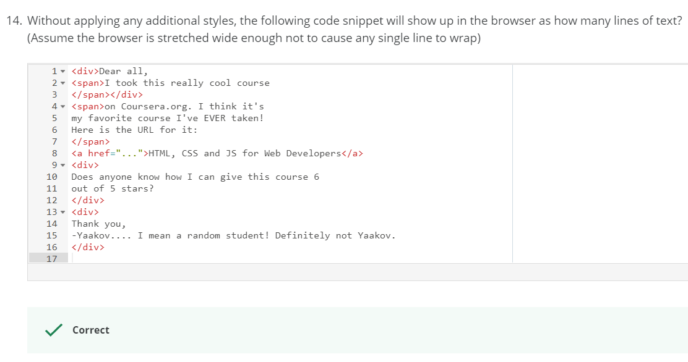

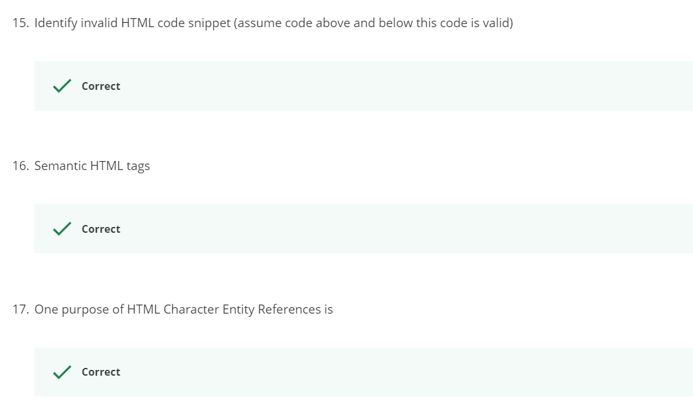

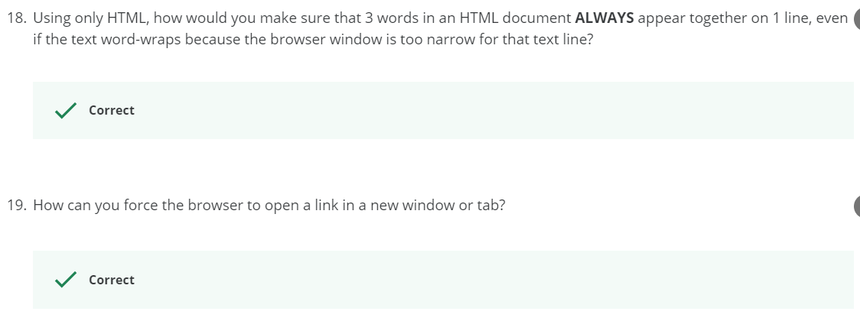

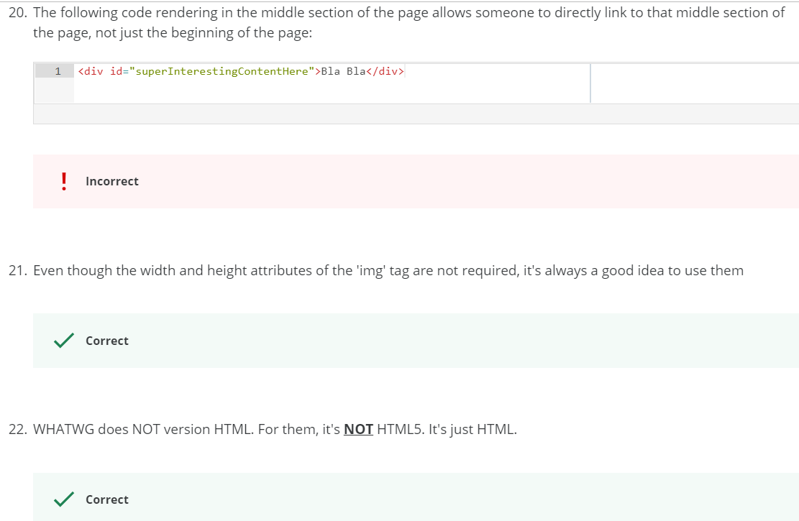

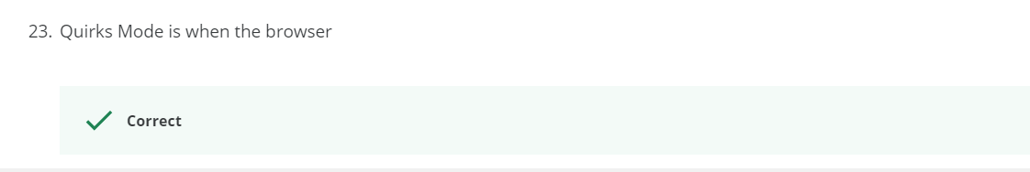

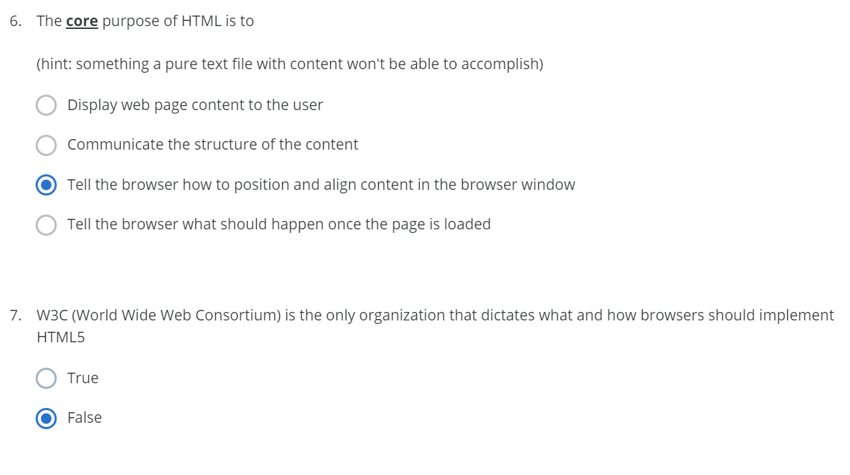



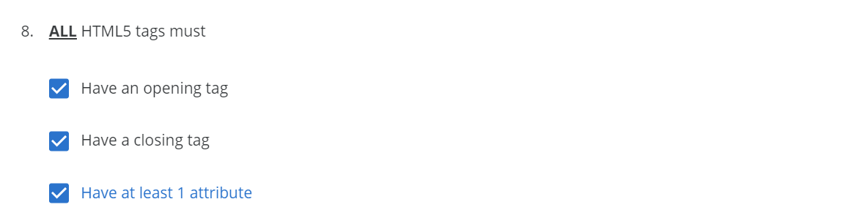



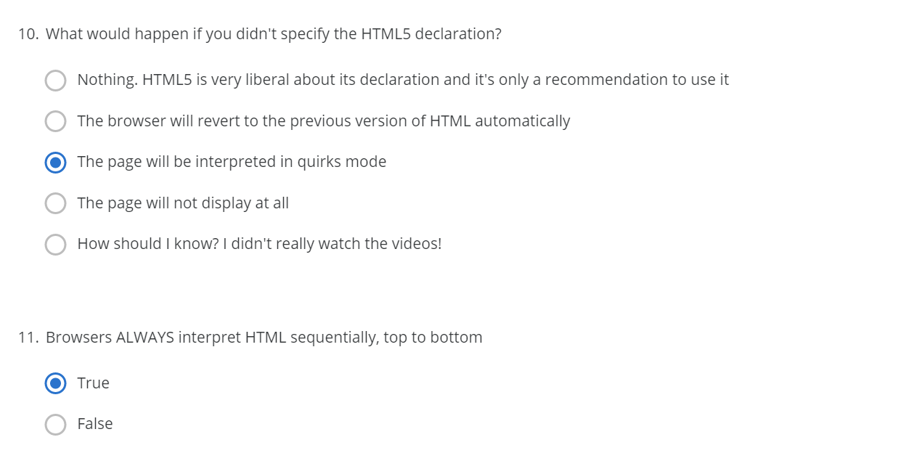

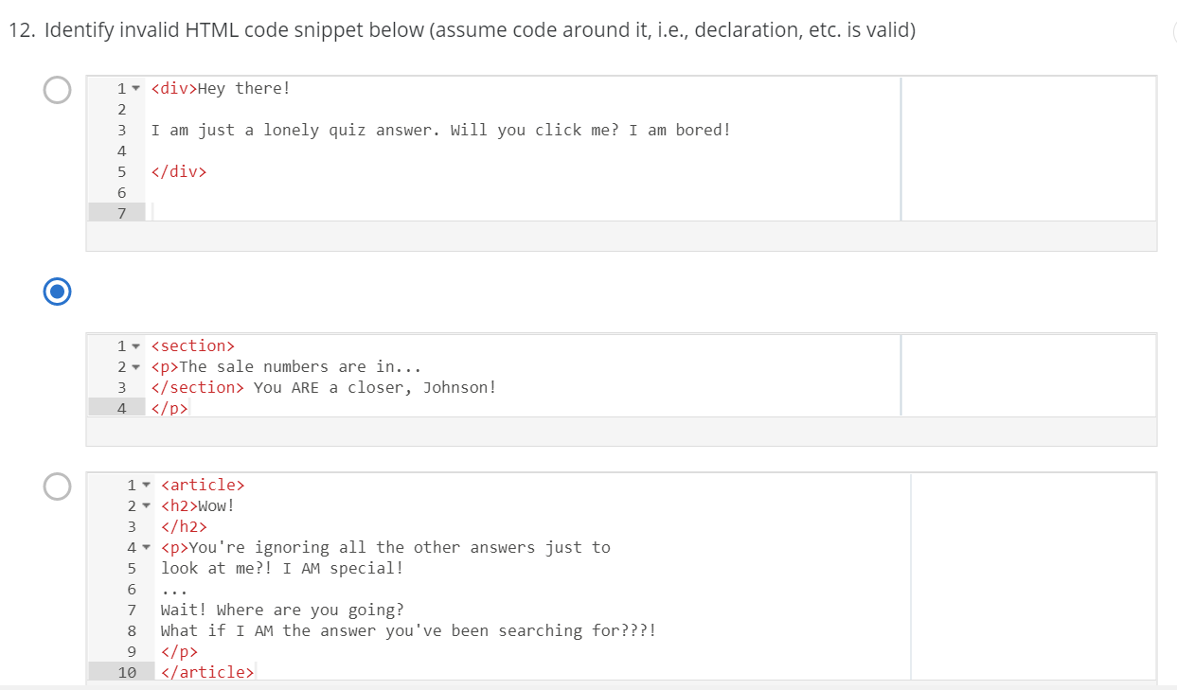

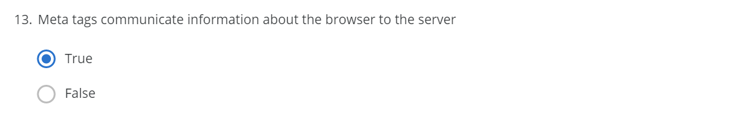



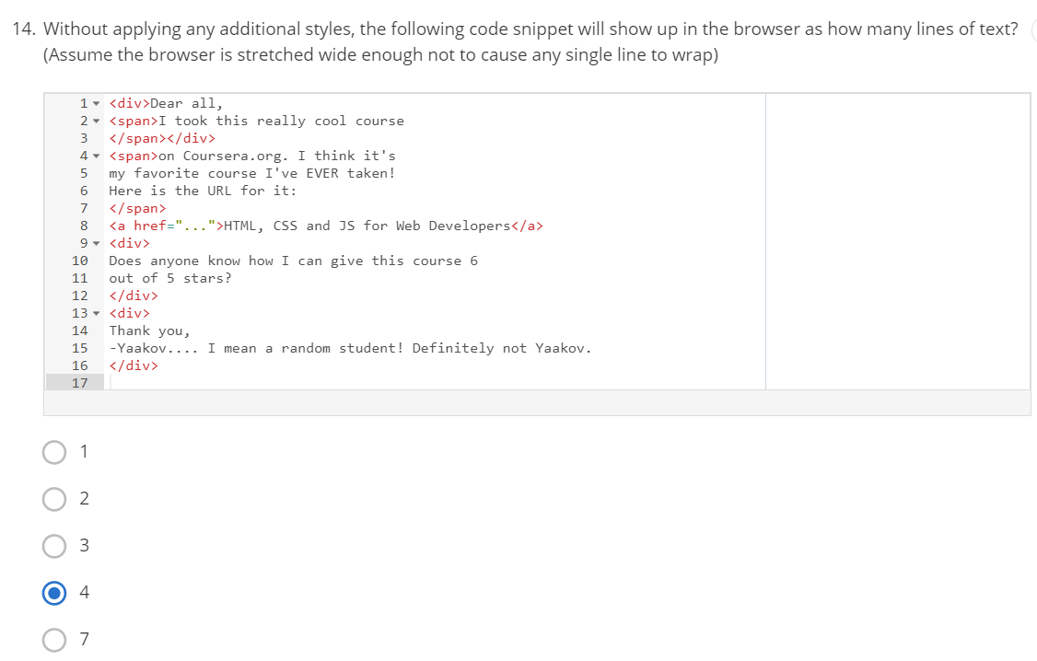

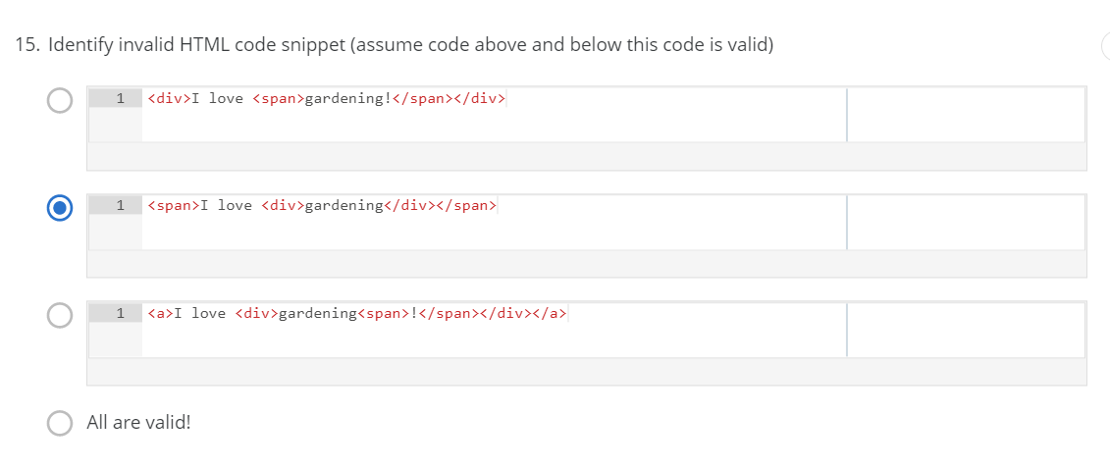

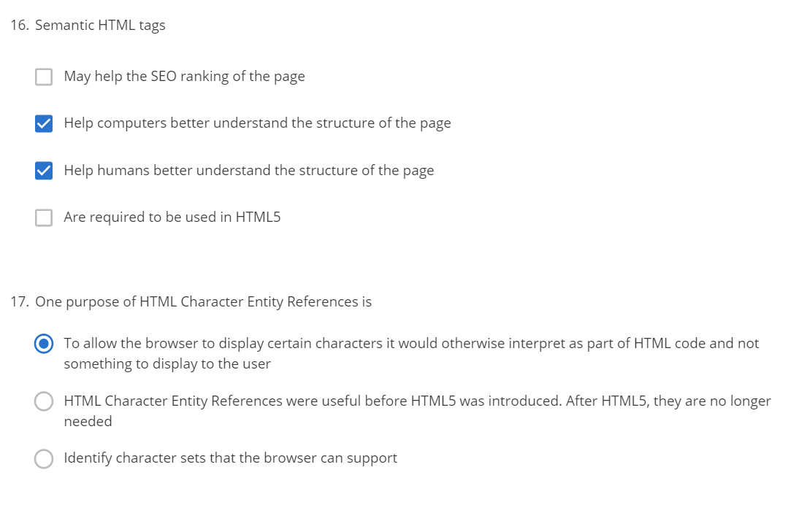



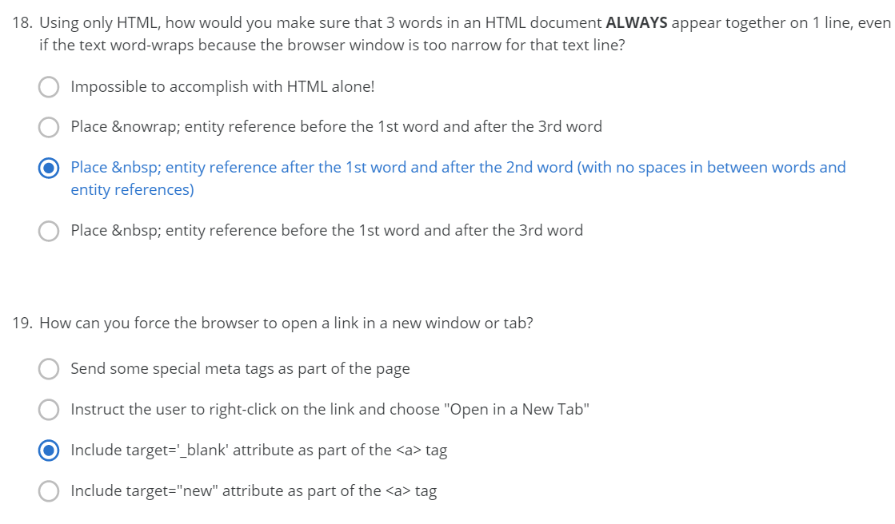

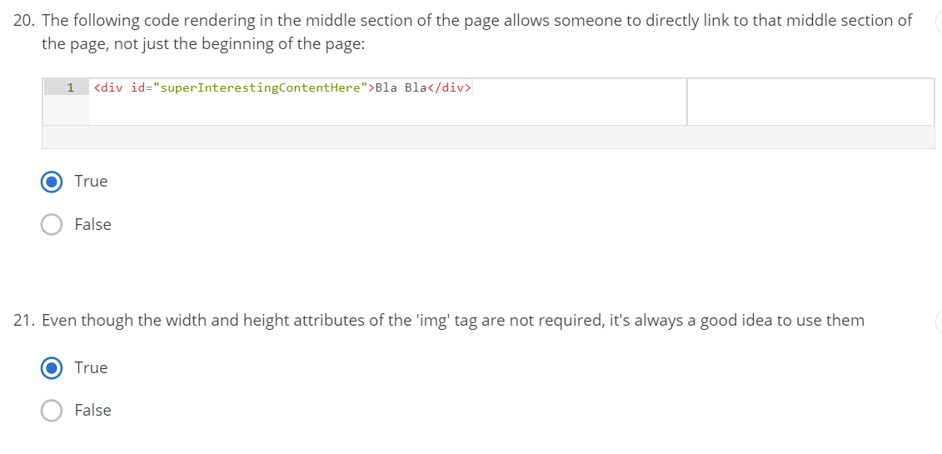

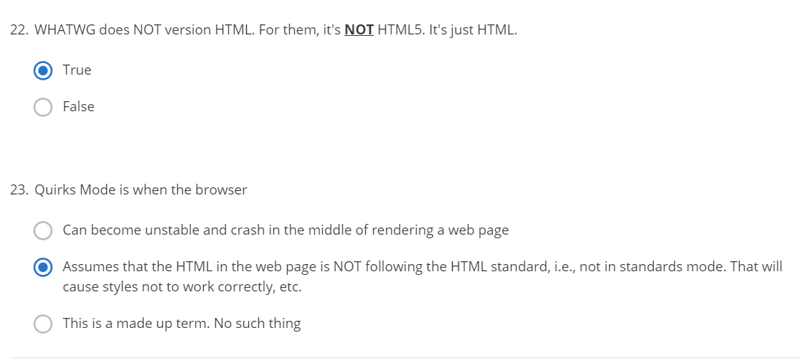

Difference between name and value in <input>

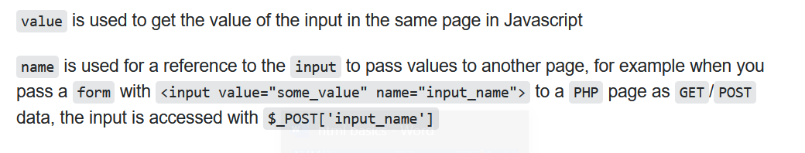

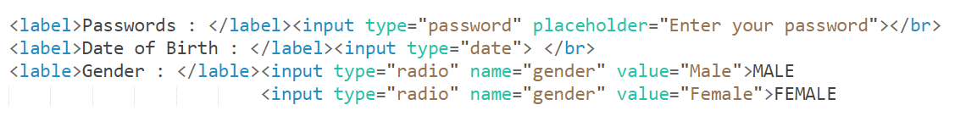

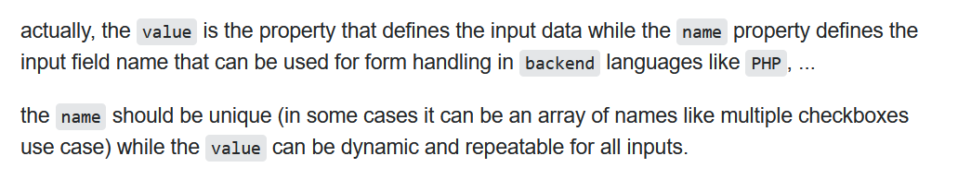

What ever you give in value, that only will be sent to the server